Sommario
Cosa vedere in Andalusia 2
GIBRALTAR 3
03.10.2026 3
Navigation to Gibraltar 3
Lista e mappa Gibraltar 4
UNTERKUNFT CADIZ 5
To visit in Gibraltar 6
Nature & The Rock 7
History & Culture 7
CADIZ 8
03.10.2026 8
Navigation to Cadiz 8
Lista e mappa Cadiz 9
To visit in Cadiz 9
Cadiz cathedral 9
Gadir archaeological site 10
Cadiz Museum 10
Tavira Tower 11
CADIZ INFO 11
SEVILLA 16
04.10.2026 – 05.10.2026 16
Navigation to Sevilla 16
UNTERKUNFT SEVILLA 17
Lista e mappa Sevilla 18
To visit in Sevilla 19
REAL ALCAZAR PALACE 19
Archivo General de Indias 20
Seville Cathedral 20
The Torre del Oro tower 21
Stierkampfarena und Stierkampfmuseum der Real Maestranza 22
María Luisa park 22
Plaza de España Square 22
Plaza América 23
Die Giralda 23
Die Pilze von Sevilla 24
Gebäude „Casa de Pilatos 25
CORDOBA 26
06.10.2026 07.10.2026 26
Navigation to Cordoba 26
UNTERKUNFT CORDOBA 27
Lista e mappa Cordoba 28
To visit in Cordoba 29
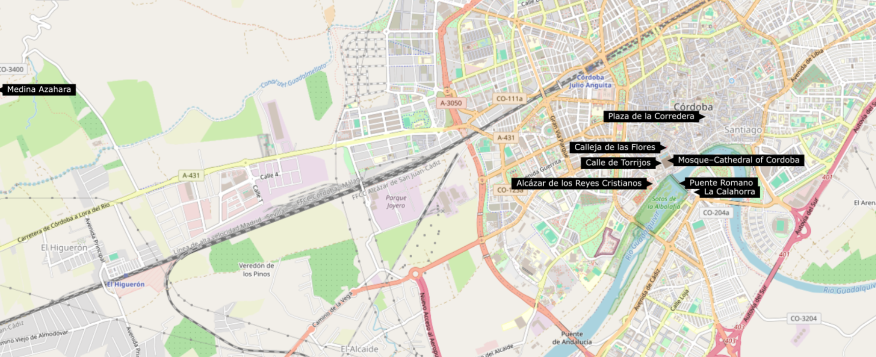 29
Medina Azahara 30
Great Mosque of Cordoba 30
Roman Bridge and Bridge Gate 31
Alcázar fortress of the Christian Monarchs 33
Festungsturm La Calahorra 33
Lebendiges Museum von Al-Andalus – Turm von Calahorra 34
Kathedrale von Córdoba 34
Plaza de la Corredera 35
Calleja de las Flores 35
Archäologisches Museum von Cordoba 36
Römischer Tempel 37
Museum „Julio Romero de Torres” 37
Equestrian Show at Caballerizas Reales 38
GRANADA 39
09.10.2026 39
Navigation to Granada 39
UNTERKUNFT GRANADA 40
Lista e mappa Granada 41
To visit in Granada 44
Alhambra 44
Museo dell'Alhambra 44
Cattedrale di Granada 45
Monastero della Cartuja 45
El Generalife 46
Granada Parque de las Ciencias 46
Málaga 48
10.10.2026 48
Navigation to Malaga 48
UNTERKUNFT MALAGA 49
INFO MALAGA 50
Lista e mappa Malaga 51
To visit in Malaga 52
Picasso-Museum Málaga 52
Park von Málaga 52
Museum Carmen Thyssen Málaga 53
Römisches Theater von Málaga 53
Centre Pompidou Málaga 54
Kathedrale von Málaga 54
Festung von Málaga 55
Soho Málaga - Das Kunstviertel 56
Mappa dell’Andalusia 58

Cosa vedere in Andalusia
  - Guida ai luoghi più belli e mappa della regione
L'Andalusia, situata nel sud della Spagna, è una terra ricca di storia, cultura e paesaggi mozzafiato. Questa regione è famosa per le sue città storiche, i suoi villaggi bianchi arroccati sulle colline, le spiagge dorate della Costa del Sol e le tradizioni autentiche come il flamenco e la corrida.

GIBRALTAR

03.10.2026

Navigation to Gibraltar

MALAGA – GIBRALTAR
1 h 54 min (136 km)
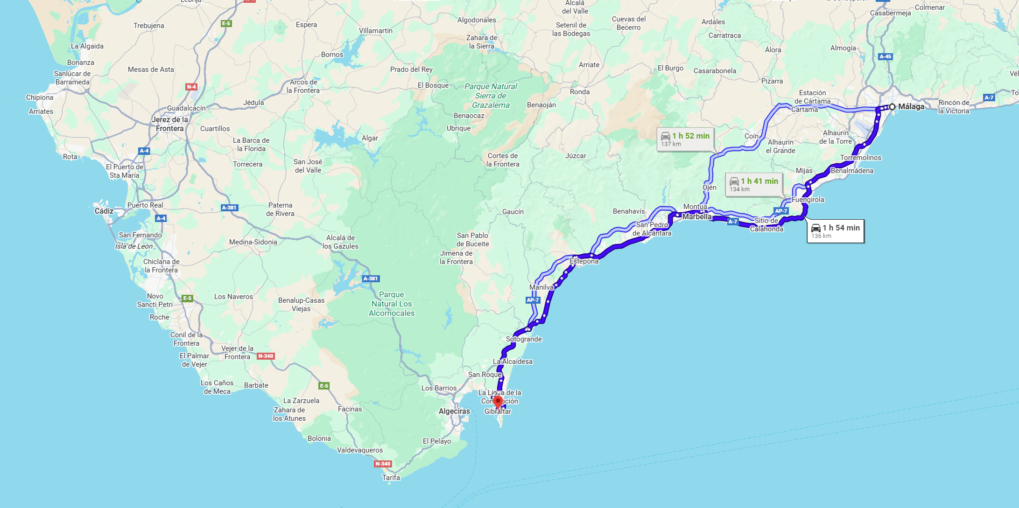
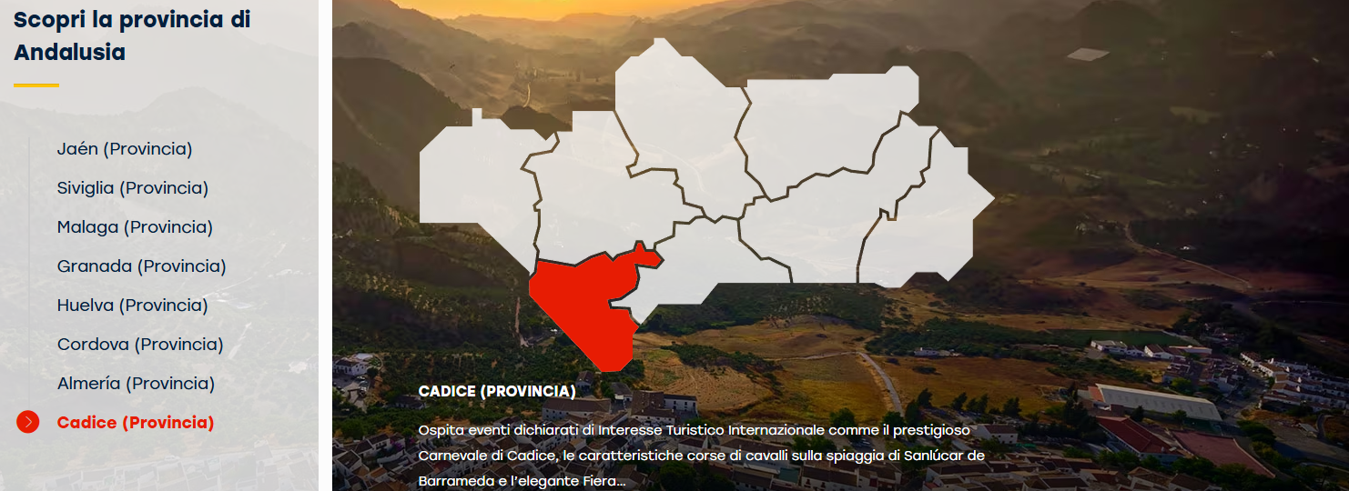

Lista e mappa Gibraltar

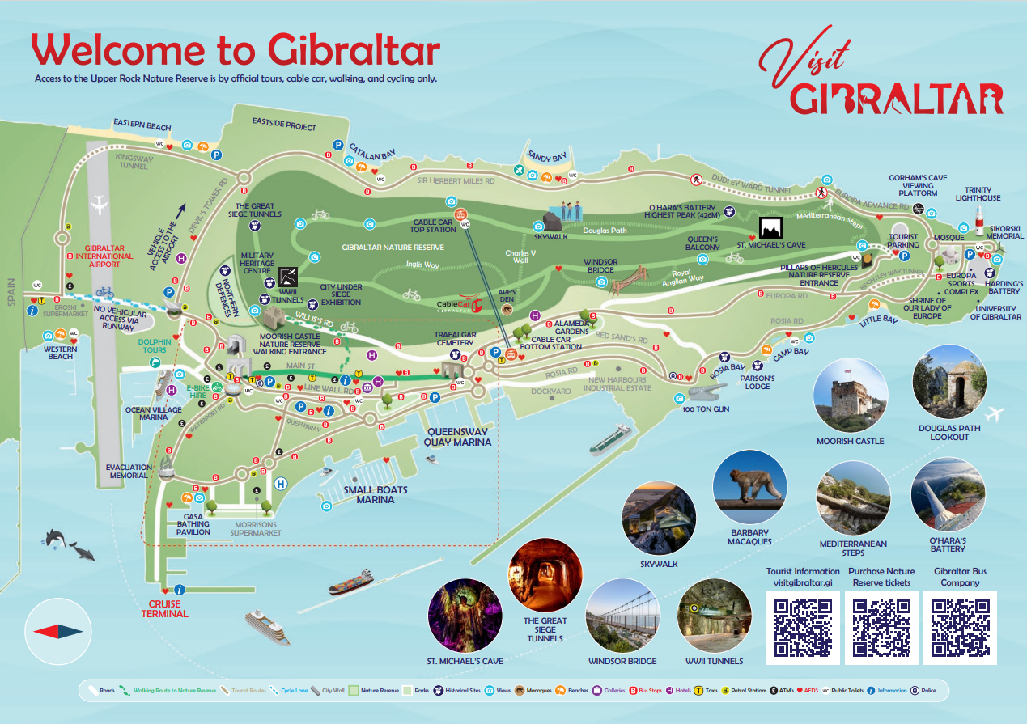
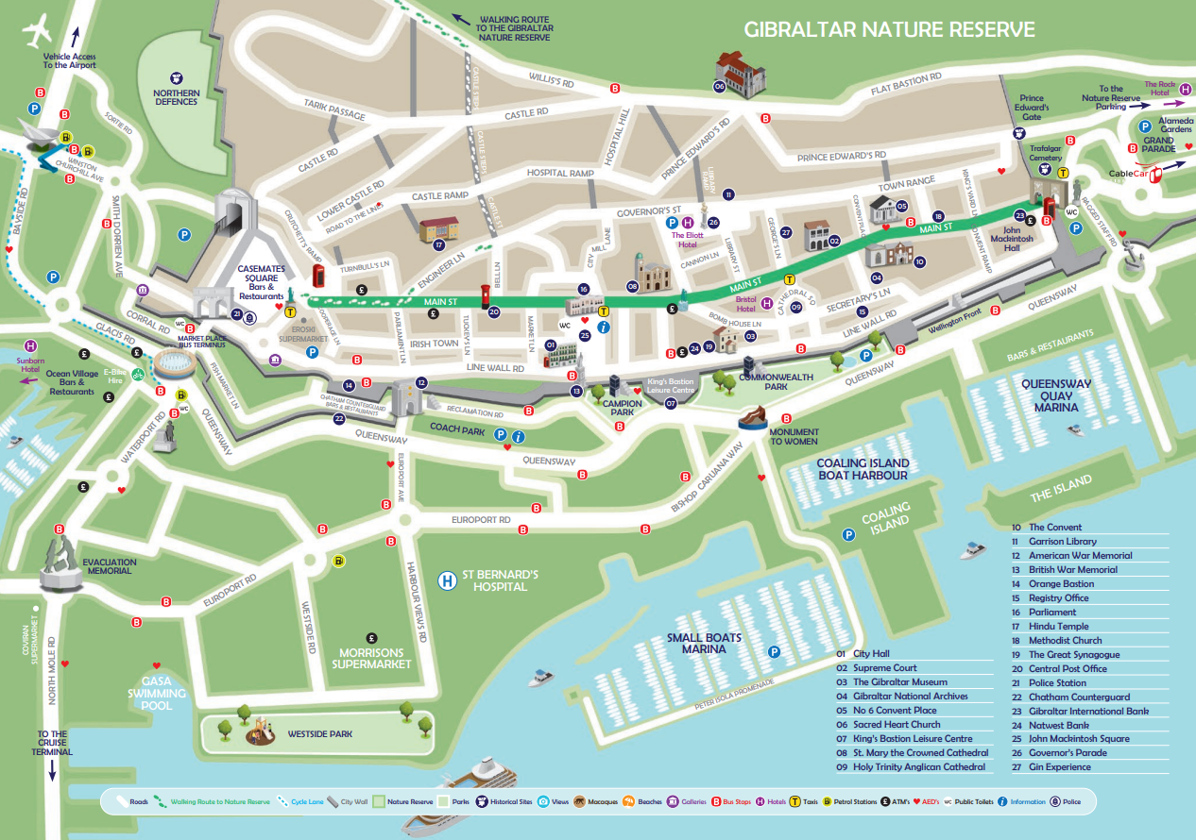

UNTERKUNFT CADIZ
DATUM 03/10/2026 bis 04/10/2026
CADIZ Hotel Regio Cádiz
Avenida Ana de Viya, 11, 11009 Cádiz
+34 956 279331
http://www.hotelregiocadiz.com/

To visit in Gibraltar
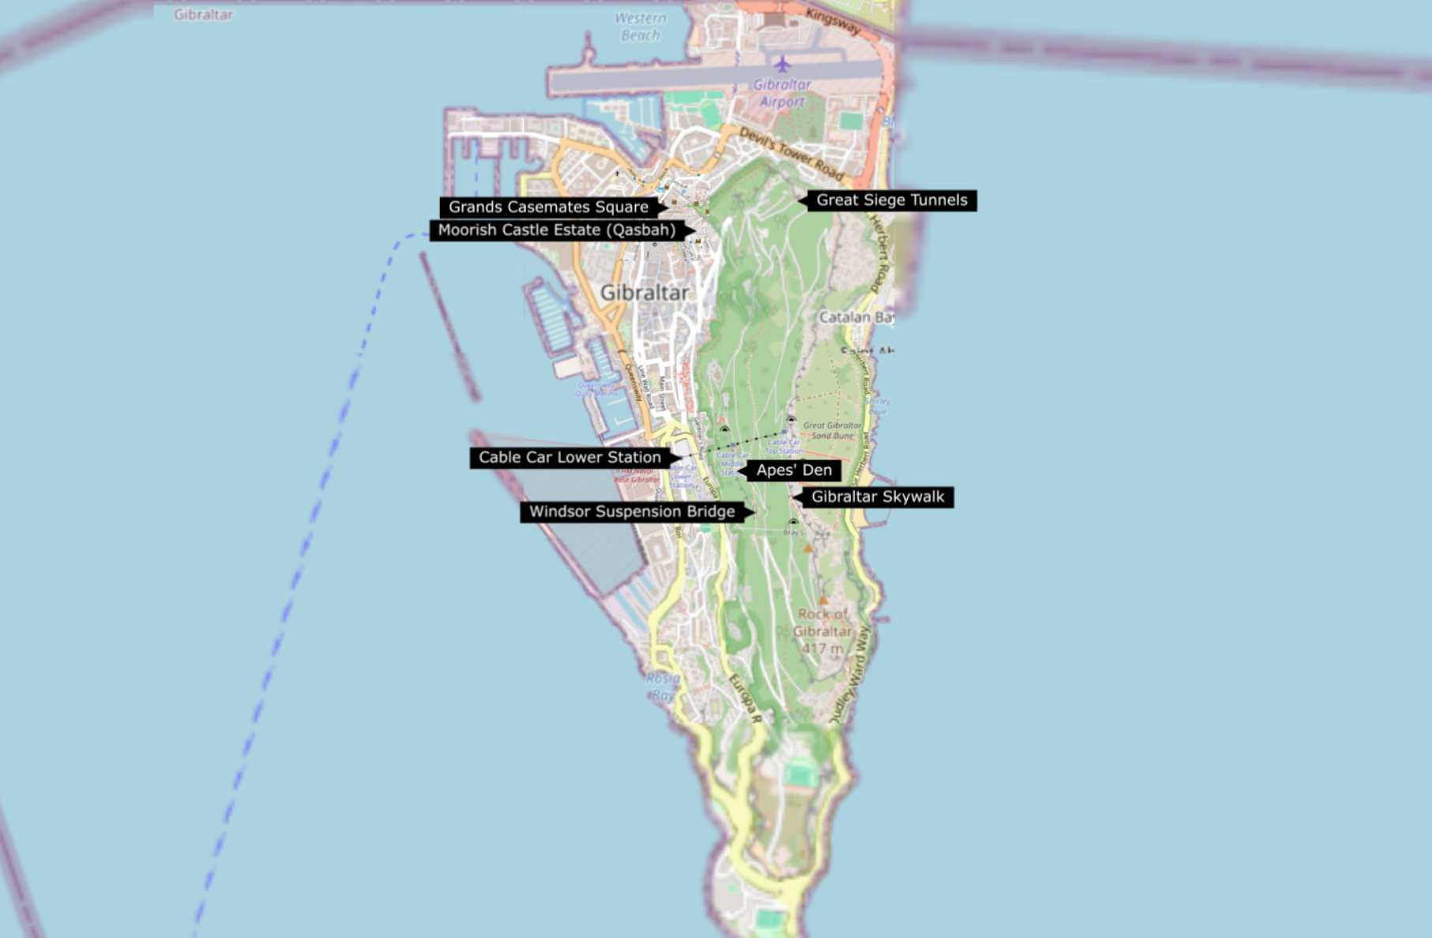

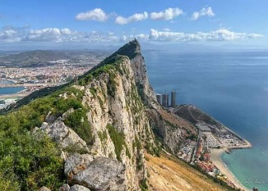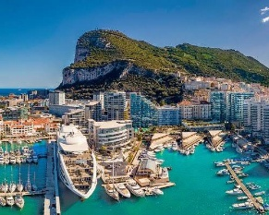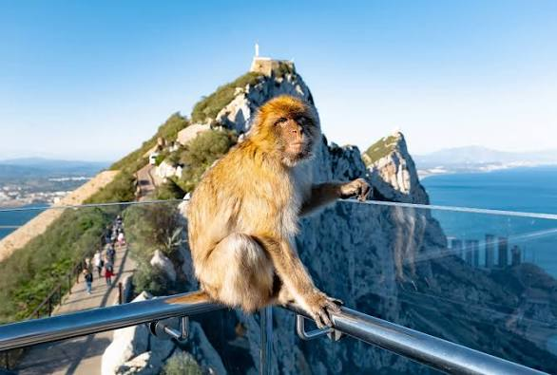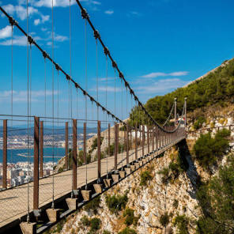
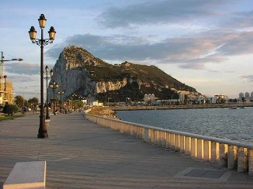
In Gibraltar, explore the iconic Rock of Gibraltar via cable car or hiking, encounter the famous Barbary Macaques, visit historic sites like the Great Siege Tunnels and Moorish Castle, marvel at St. Michael's Cave, walk the Windsor Suspension Bridge, and enjoy views from the Skywalk, all while experiencing lively areas like Casemates Square and Europa Point. Boat trips for dolphin watching are also popular, and you can delve into local culture in Main Street and Irish Town.
NICHT MIT DEM AUTO NACH GIBERALTAR vor der Grenze gibt es Parkplaetze

Nature & The Rock

- The Rock of Gibraltar Nature Reserve: Home to the famous Barbary Macaques, St. Michael's Cave, the Skywalk, Windsor Suspension Bridge, and the Great Siege Tunnels.
- St. Michael's Cave: A stunning natural cave system within the Rock.
- Windsor Suspension Bridge: A thrilling walkway offering panoramic views.
- Apes' Den: See the resident Barbary Macaques up close.
- Europa Point: The southernmost tip, featuring a lighthouse and the Ibrahim-Al-Ibrahim Mosque.
- Dolphin Watching: Take a boat tour in the Bay of Gibraltar.

History & Culture
- Great Siege Tunnels & WWII Tunnels: Explore tunnels carved into the Rock for military defense.
- Moorish Castle: A historic castle with a prominent tower.
- Skywalk: A glass viewing platform offering incredible vistas.
- Casemates Square: A bustling public square with restaurants and entertainment.
- Main Street & Irish Town: Shop, dine, and soak in the atmosphere of the old town.
- Gibraltar National Museum: Learn about the territory's rich history and culture.

CADIZ

03.10.2026

Navigation to Cadiz

GIBRALTAR - CADIZ
1 h 45 min (121 km)
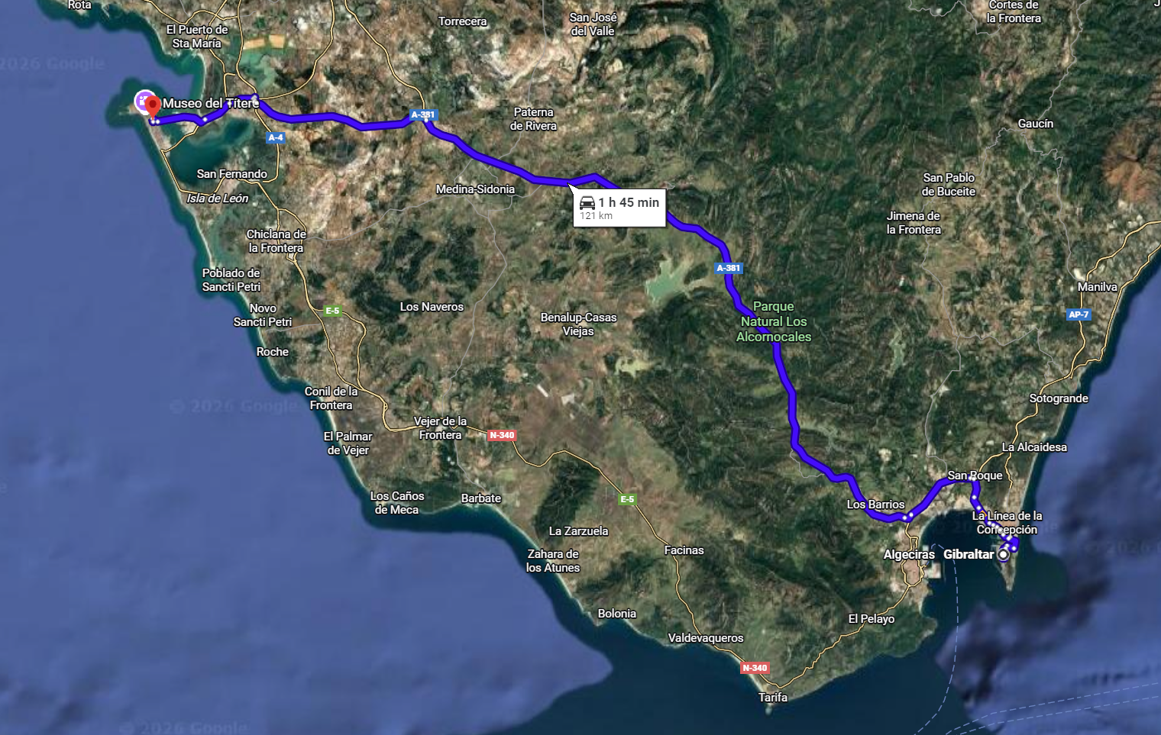

Lista e mappa Cadiz

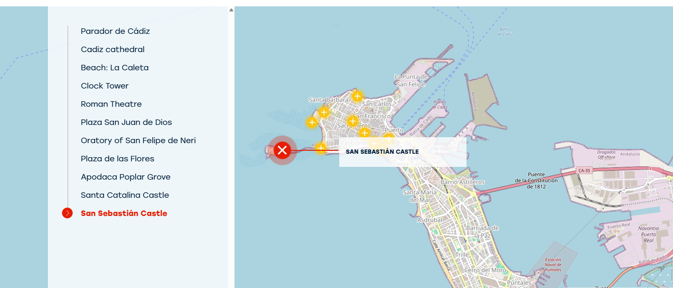

To visit in Cadiz

Cadiz cathedral
Plaza Catedral s/n
11005 Cádiz, Cadiz (Andalusia)
gelen@vocces.com
Tel.:+34 956286620
Tel.:+34 956286154
http://www.catedraldecadiz.com/

Falla's final resting place
It took 116 years to complete, so the mix of styles is evident. Construction began in the Baroque style and was completed in the neoclassical style. There are works of sculpture from the old cathedral on the interior.
The towers and the sacristy were the last elements to be built in the 19th century. Particular highlights include the vaults of the high altar and the choir stalls, although the latter were not originally from the cathedral. There are some very beautiful Baroque images. The church is crowned with a dome of golden tiles which gives it an imposing appearance. The famous composer Manuel de Falla is buried in the crypt.
Since 2003, the Torre de Poniente tower has become a new tourist attraction in the city. The bell tower, whose construction began in Cadiz’s golden age in the 18th century, can be reached via the ramp. The top of the tower affords outstanding views over the city below.

Gadir archaeological site
A place with nearly 3,000 years of history where visitors can discover the first traders who lived in Cadiz, Andalusia. The different periods of habitation on the site are reflected in the layout of the streets, homes and tools dating to the 9th century BC, which can be seen on the tour.
Calle San Miguel, 15
11001 Cádiz, Cadiz (Andalusia)
cadiz2012@cadiz2012.es
+34 956226337
www.turismo.cadiz.es/
cadiz2012@cadiz2012.es

Cadiz Museum
Phoenicians, Romans and Spaniards

The museum offers a journey that goes from Phoenician and Roman culture through to 20th century Spanish painting.
The Museum is divided into three sections: Phoenician and Roman archaeological artefacts, with outstanding Phoenician sarcophagi from the 5th century BC; Fine Art, with paintings from the 16th-20th centuries, including works by Zurbarán, Murillo and Rubens; Ethnography, where you can see Tía Norica traditional puppets, an example of Costumbrism in the Cadiz of the 19th and 20th centuries.
Plaza de Mina, s/n
11004 Cádiz, Cadiz (Andalusia)
museocadiz.ccul@juntadeandalucia.es
Tel.:+34 856 105 023
http://www.museosdeandalucia.es/web/museodecadiz
Tavira Tower

Tavira Tower

C/ Marqués del Real Tesoro, 10
11001 Cádiz, Cadiz (Andalusia)
reservas@torretavira.com
Tel.:+34 956212910
https://torretavira.com

The official watchtower of the port of Cádiz in the 18th century, the Tavira Tower is the highest point in the city. Its main attractions are the camera obscura, and the stunning views from its viewpoint.
Located in Casa Palacio de los Marqueses de Recaño in the old quarter, the Tavira Tower is one of the most important tower viewpoints in Cadiz. As well as the magnificent panoramic view that it offers, there are two exhibition rooms, and a camera obscura that projects a real-time moving image of what’s happening outside. A device consisting of a white screen, a mirror, and magnifying lenses is what makes it possible to enjoy this unusual optical effect. Opened in 1994, this was the first camera obscura in Spain, and is today one of the city’s main tourist attractions.

CADIZ INFO

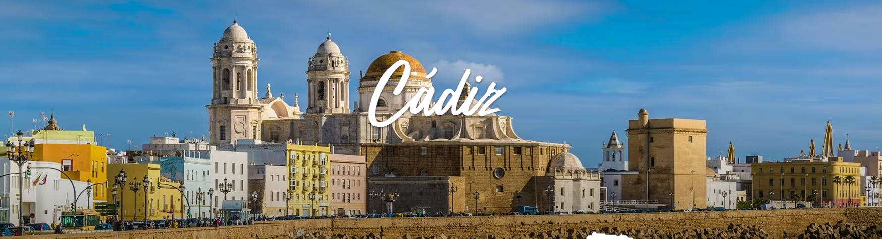

Discover the secrets of the city affectionately known as the 'Tacita de Plata' ('the little silver cup').
It’s said that this city in Andalusia is the most ancient in the Western world. In fact it was founded by the Phoenicians in 1100 BC. To really get a feel for Cadiz, you simply have to take a stroll along the seafront promenade, while you admire the spectacular golden dome of the cathedral, explore the narrow streets of the city’s traditional neighbourhoods like El Pópulo, tuck into a plate of pescaíto frito (little fried fish), and chat with the locals. We’re going to tell how you can experience the very best of Cadiz in just one day.
MORNING
Morning is the time to discover some of the city’s most famous monuments, such as the Cathedral, before having a bite to eat in the Central Market.
After a nice breakfast (for example you could stay overnight in the modern Parador de Cádiz and enjoy your breakfast while taking in the views out over the bay), the best idea is to head straight for the most famous of the city’s monuments: Its Cathedral. It combines baroque and neoclassical styles. If you want to get to know it in depth, why not take one of the tours that will give you access to little known parts of the building, like the crypt. You could also visit the Casa de las Contadurías or the Clock Tower, from where there’s a magnificent view of the typical white towers of the city against the backdrop of the sea.
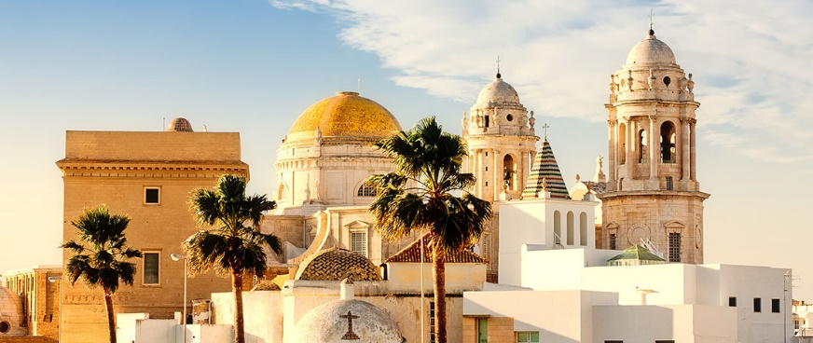
Afterwards, it’s time to take a stroll through the El Pópulo neighbourhood, the oldest in Cadiz. You can walk inside through three 13th-century arches that used to provide access to the old medieval city: Pópulo, la Rosa and los Blancos. You can wander through the streets, stopping off at places like the Plaza San Martín and the Roman Theatre, which dates from the 1st century BC. This way you’ll come to the wide, beautiful Plaza de San Juan de Dios, with its emblematic buildings like the one that houses the City Council.One of the most surprising places in the city is only a 10-minute walk away: Tavira Tower. The tower was built many years ago by the city’s merchants, who wanted to be able to see their ships and cargoes arrive safely. If you climb up the 173 steps, you’ll find yourself in what for many is the best viewpoint in all of Cadiz. It also keeps a secret: a dark chamber, which will surely surprise you. Really close by stands the San Felipe Neri Oratory, where the first Spanish Constitution was drafted in 1812.
Left: View of Cadiz from the Tavira Tower / Right: Plaza San Juan de Dios in Cadiz, Andalusia
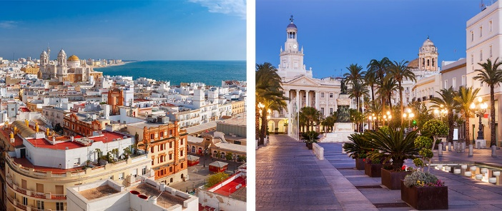
The final stop off point before lunch is the pretty, triangular Plaza de las Flores, always so lively and colourful that you’ll feel like spending a good while there. You’ll find a range of cafés which have terraces where you can enjoy the typical churros of Cadiz, and a few famous fried fish establishments. However, if you are hungry after a busy morning, the perfect place is right next door: In the famous Central Market.This market was built in 1838, on the site of an allotment that belonged to an old convent. Despite having been totally refurbished, the architecture, and above all the explosion of life, are still impressive two centuries on. More than 100 stall selling some of the world’s best fish, such as tuna and Barbate tuna, lots of different types of olives, pastries, and much more. You’ll really enjoy tucking into something delicious in the market’s Rincón Gastronómico, which serves up all kinds of international as well as local dishes at the outdoor tables.
AFTERNOON
The afternoon could be spent wandering through one of the city’s gardens, and discovering its castles.
After a good meal, a stroll through a garden is sure to appeal. Try the leafy green world of the Apodaca Poplar Grove, and look out over the sea as you walk, or head for the pretty Genovés Park, which is the largest green area in the old quarter, and take a seat by the lake. There’s even a waterfall.
Left: Aerial view of Cadiz and San Sebastián Castle / Right: Santa Catalina Castle in Cadiz, Andalusia
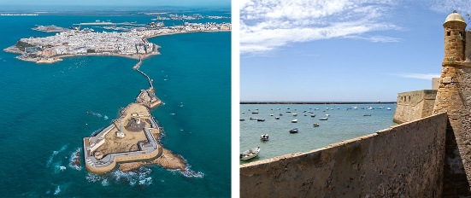
Following the coast, you’ll come to Santa Catalina Castle, the oldest fortress in Cadiz, which offers unforgettable views out over the Atlantic. And a panoramic view of the famous La Caleta beach, a great place for a refreshing swim. This beach, the only one in the centre, is a must if you travel to Cadiz. You will find one of the most idyllic landscapes of the city: the white Spa of La Palma sits on the sand, with San Sebastián castle in the background, towering over the sea.
La Caleta beach in Cadiz, Andalusia
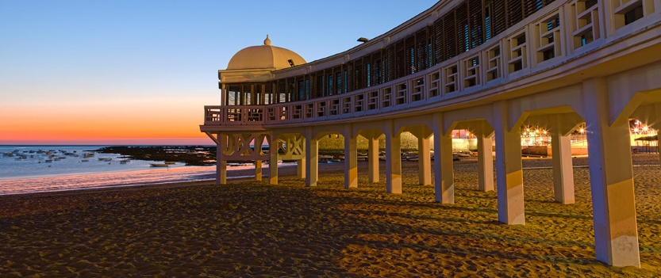
This 18th century castle stands on a tiny island that you can reach on foot via a long breakwater - a walk that’s a feast for the senses. By the way, did you know that La Caleta beach has appeared in films such as "Die another day" - one of the Bond series - in which actress Halle Berry takes a dip in its waters?Say goodbye to the day by wandering along the Avenida Campo del Sur seafront promenade while you watch the sun go down, with the Cathedral always in the background.
NIGHT
It’s dinner time, and time for a last experience that’ll leave you with good memories of Cadiz.
The tapas bars of Calle Zorillo are a brilliant option for dinner, and a great opportunity to try all sorts of different typical dishes. Also in La Viña neighborhood the streets of San Félix and La Palma and the Plaza del Tío de la Tiza square are famous for their fried fish (you must try their traditional shrimp omelette) and in summer one of the typical dishes of Cadiz gastronomy: mackerel with “piriñaca” (minced tomato, pepper and onion with virgin olive oil and sherry vinegar).
Left: Plate of pescaíto frito (little fried fish) - Right: The La Viña neighbourhood in Cadiz,
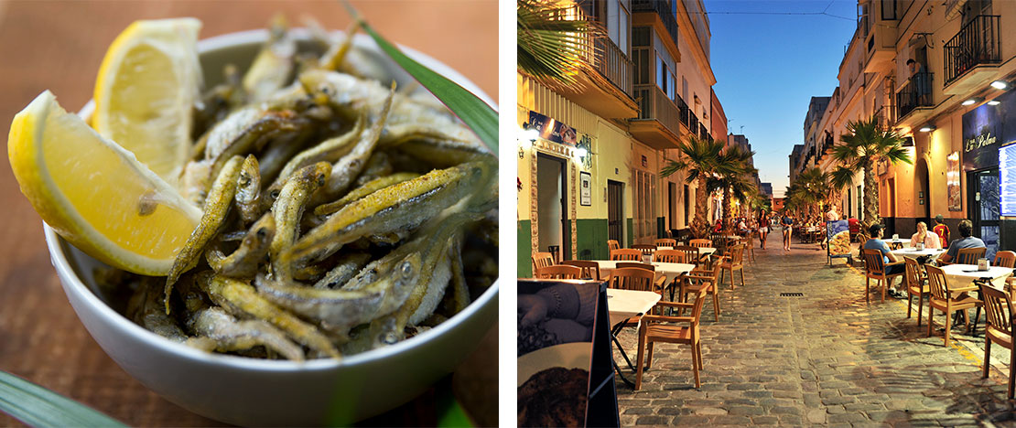
Places not to be missed
What to see
- Beach: La Caleta
- Roman Theatre
- Plaza San Juan de Dios
- Oratory of San Felipe de Neri
- Plaza de las Flores
- Santa Catalina Castle
- San Sebastián Castle

Beaches
As well as the La Caleta beach, outside the old quarter you’ll find other, less well-known beaches, such as Cortadura and Santa María del Mar. There’s also the very popular urban Victoria beach, which stretches for almost three kilometres, a broad seafront promenade, and a huge variety of restaurants.
Museums
If you’re spending more than one day in the city, you might like to visit some interesting museums such as the Cadiz Museum with its famous Phoenician sarcophagi, the Puppet Museum (especially if you’re travelling with children), or the Las Cortes de Cádiz Museum.
Founded 3,000 years ago by the Phoenicians, Cádiz is the oldest city in Western Europe.
The different peoples who settled here left an important cultural imprint, whose influence still remains in the character of the city's people. This peninsula, right on the Andalusian Atlantic coast, has been able to preserve an important historical legacy - the result of its commercial importance - together with excellent beaches and an exquisite regional cuisine. The Costa de la Luz, divided between the provinces of Huelva and Cádiz, also offers a multitude of destinations combining culture and leisure. And, for nature lovers, there is nothing better than touring the Doñana National Park, declared a World Heritage Site by UNESCO.
The former Phoenician Gades and Roman Gadir experienced its most splendid period when, in the 17th Century, it had the Ultramar (Spanish overseas empire) trade monopoly. This rise attracted attacks by pirates, which made the city fortify itself, constructing defensive bastions, castles and watchtowers on each flat roof. These are some of the characteristics of the city, in which the balcony railings are also outstanding. A visit might begin in Puerta Tierra, the entry point through the walls and the dividing line between modern and old Cádiz. On one side, wide avenues, beaches (La Victoria, Santa María and La Cortadura), sailing clubs and modern sporting facilities. On the other, a Cádiz with more flavour and history, that of the old districts: El Pópulo, the old medieval town; La Viña, fishing district and centre of the local tradition of satirical verses, or Santa María, living temple to flamenco. Streets with distinct characters but which have maintained a uniformity in the look of their houses which together form an exceptionally beautiful pattern.On the Atlantic front rise the dome and yellow tiles of the Cathedral, looking towards Campo del Sur. Baroque and Neoclassical in style, its crypt guards the remains of the composer Manuel de Falla. Beside it are the old Roman theatre and the old cathedral.What was a royal square, parade ground and market, originating on land won from the sea, is also worth a visit. This is the Plaza de San Juan de Dios where the Neoclassical structure of Cádiz City Hall stands, looking towards the nearby port.Many lively squares lie along any route. In the Plaza de España, beside the port, stands the palace of the Provincial Government and Monument to the Liberal Cortes (Parliament). In the tree-lined Plaza Mina you can visit the Cádiz Archaeological and Fine Arts Museum, which has interesting Phoenician exhibitions, while in the Plaza de San Francisco you can visit the church of the same name. The city's most important shopping streets begin around the Plaza de las Flores. There is a good reason why the Central Market located here. Another square, that of Tío de la Tiza, is the heart of the district of La Viña, where the Carnival, a Festival of International Tourist Interest, begins with the traditional satirical verses.Cádiz has important religious buildings that tell us of Andalusian religious feeling. In Santa María, the church that gives its name to the district and the Convent of Santo Domingo are important. Near La Viña the parish church of La Palma awaits, while at the other end of the city, next to Candelaria Bastion, stands the church of Carmen. Right in the centre of Cádiz you can visit the Cádiz Municipal Historical Museum, the Tavira Tower, one of the most symbolic in the city, and the Oratory of San Felipe Neri, a National Monument in which the Liberal Constitution of 1812 was debated.And for the best views of the Atlantic Ocean there is nothing like a stroll in the garden walks of the Alameda de la Apodaca, the Genovés Park and La Caleta beach. This beach is the only one is the old town and is framed by the Santa Catalina and San Sebastián castles. Its sands give way to the bathing area of La Palma and El Real. You can continue as far as the beaches of the modern city, passing through Campo del Sur and stopping at the Mártires, Capuchinos and San Roque bastions.The former Gades offers you its Parador de Turismo, the “Hotel Atlántico”. Staying in the heart of the old town in a room with sea views is ideal preparation for tasting the rich cuisine of Cádiz. The capital brings together the wealth of the whole province and offers us langoustines from Sanlúcar, sole from San Fernando, wines from Jerez (sherry) and Cádiz "turrón" (a kind of nougat). Cold meats include Iberian ham, always from the mountains of the interior.The exceptional geographical position of Cádiz enables you to go to beautiful places like the Costa de la Luz, El Puerto de Santa María, Puerto Real (whose old quarter is a historic-artistic site) or Chiclana de la Frontera. At the western end of the Cadiz coast lies Sanlúcar de Barrameda, well known for its manzanilla, with Denomination of Origin, and for being one of the entrances to the Doñana Natural Park, declared a World Heritage Site.Inland, Jerez de la Frontera awaits, a city with one of the most famous wines in Spain, (also with Denomination of Origin) and home to the "cartujano" horses. It is a good starting point for doing the White Villages Route. This way you will discover Serranía de Ronda - the natural parks of Grazalema and Los Alcornocales - as well as places with impeccable white houses like Arcos de la Frontera, Medina Sidonia or Vejer de la Frontera. Another highly recommended tour is the Roman Bética Route, which takes you to places in the former Roman province, from Santiponce (Seville) to Tarifa (Cádiz), a good place for walking in the old town and going windsurfing.

SEVILLA

04.10.2026 – 05.10.2026

Navigation to Sevilla

CADIZ- SEVILLA
1 h 35 min (127 km)
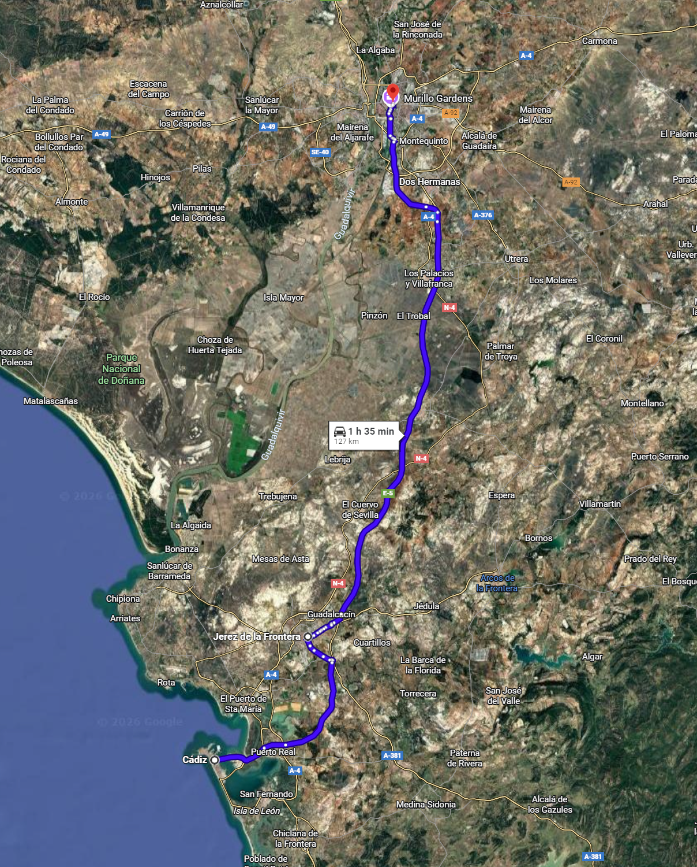

UNTERKUNFT SEVILLA
DATUM 04/10/2026 bis 06/10/2026
SEVILLA Hotel Palace Sevilla
Plaza de la Encarnación, 17, Altstadt,
41003 Sevilla, Spanien
+34 955 310 909
http://www.hotelpalacesevilla.es

Lista e mappa Sevilla
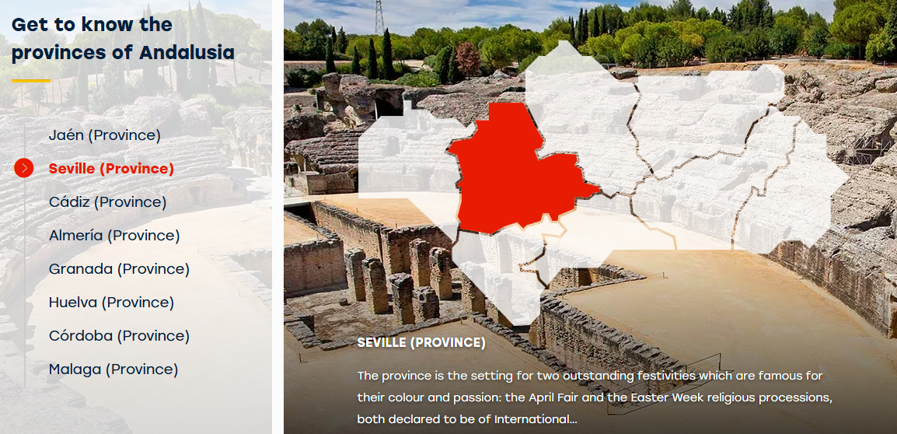

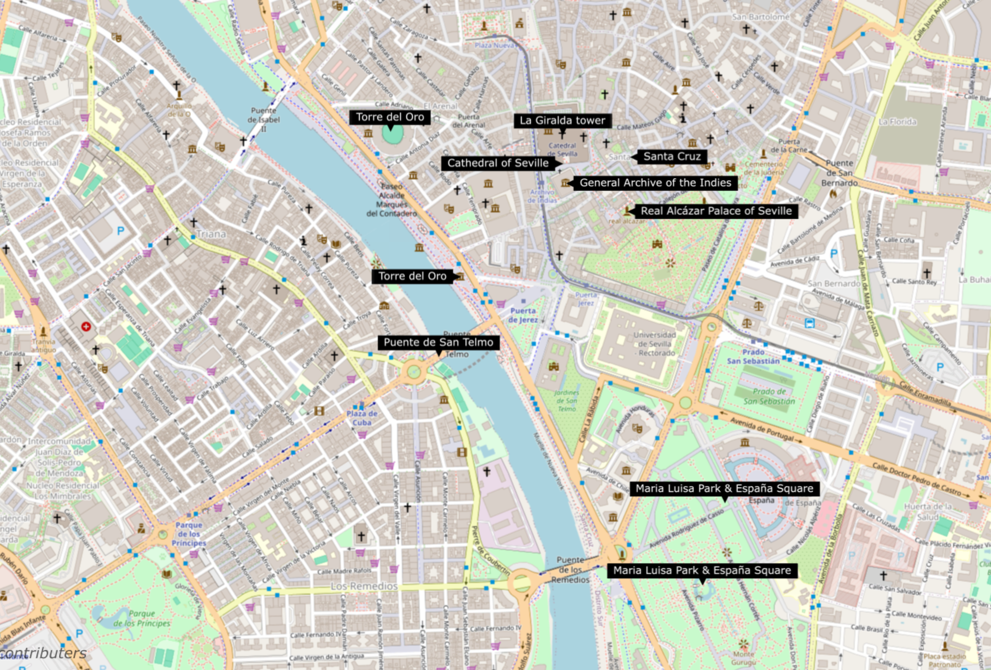

To visit in Sevilla

REAL ALCAZAR PALACE
http://www.patronato-alcazarsevilla.es
https://alcazardesevilla.infoticketing.com/de/entradas/visita-real-alcazar-cuarto-real-alto
Octubre-marzo: 9.30-17 horas
Enthält:
* Besuch der Paläste und Gärten des Königlichen Alcázar von Sevilla
* Besuch der Königlichen Oberen Gemächer (Cuarto Real Alto).
Bedingungen:
* Nach erfolgter Zahlung sind keine Änderungen oder Rückerstattungen möglich.
* Haustiere sind nicht erlaubt, ausgenommen Blindenhunde oder Hunde zur emotionalen Unterstützung mit entsprechender Dokumentation.
* DER ZUTRITT MIT GETRÄNKEN (außer Wasser) UND LEBENSMITTELN/ESSEN (außer für Babys) IST VERBOTEN.
* Alle Eintrittskarten sind personalisiert. Jeder Besucher muss VERPFLICHTEND SEINEN PERSONALAUSWEIS ODER REISEPASS ZUSAMMEN MIT DEM TICKET an der Zugangskontrolle vorzeigen.
* ALLE ermäßigten Tarife müssen durch entsprechende Unterlagen nachgewiesen und an der ZUGANGSKONTROLLE zur Anlage (LÖWENTOR – Puerta del León) vorgelegt werden.
* KOSTENLOSE EINTRITTSKARTEN für in Sevilla-Stadt Geborene und/oder dort Ansässige erfordern die Vorlage eines Personalausweises, Reisepasses oder einer aktuellen Meldebescheinigung der letzten 3 Monate.
Bitte beachten:
* Sie können Ihre EINTRITTSKARTE ausgedruckt oder auf dem Mobiltelefon vorzeigen.
* Der Zugang zum Monument durch das LÖWENTOR ist von 60 Minuten vor bis 30 Minuten nach der auf dem Ticket angegebenen Uhrzeit möglich.
* Das Monument wird von Oktober bis März um 17:45 Uhr und von April bis September um 19:45 Uhr geräumt.
* Der Besuch der Gärten hängt von den Wetter- und Sicherheitsbedingungen für die Besucher ab; die Gärten können ohne vorherige Ankündigung geschlossen werden. Dies begründet keinen Anspruch auf eine vollständige oder teilweise Rückerstattung des Eintrittspreises.

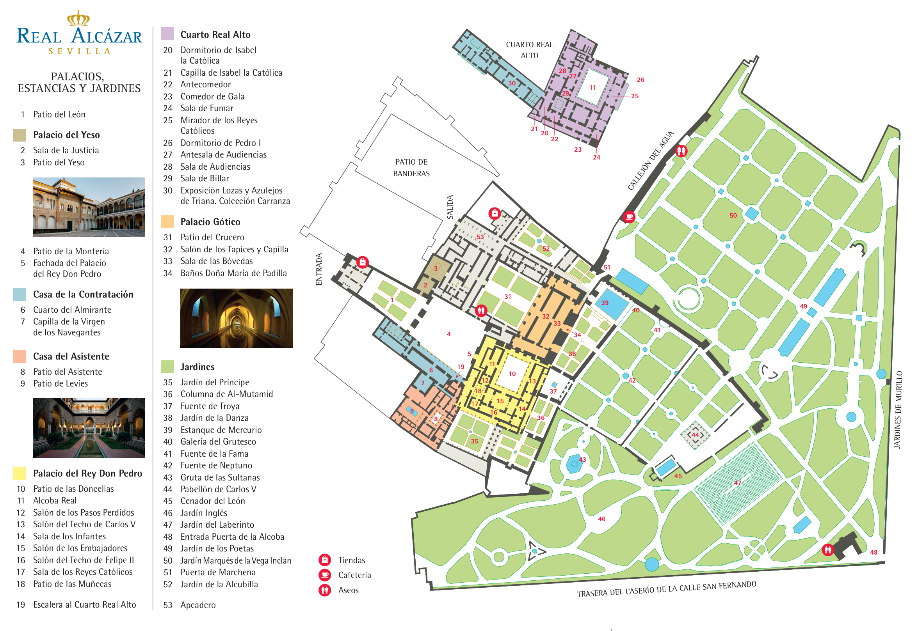

Archivo General de Indias
Das Gebäude La Lonja
Avenida de la Constitución, 3
41071 Sevilla (Andalusien)
E-Mail: agi2@cultura.gob.es Tel.:+34 954 211 234 Tel.:+34 954 500 528
https://www.andalucia.org/es/sevilla-turismo-cultural-archivo-general-de-indias
Precios Orientativos
Eintritt freu
Fechas: 1 de enero de 2026 - 31 de diciembre de 2026
Día
Lunes | Cerrado
Martes - Sábado | 09:30 - 16:30
Domingo | 10:00 - 13:30
Día festivo | 10:00 - 13:30
Grupos con cita previa

Der Bau des Archivo General de Indias, früher Lonja de Mercaderes (Warenbörse), begann Ende des 16. Jahrhunderts. Das Gebäude wurde von Juan de Herrera entworfen und von Alonso de Vandelvira und Juan de Minjares gebaut. Der erste Stock und das Schwurkreuz an der Außenseite stammen aus dem 17. Jahrhundert. Ein Jahrhundert später, als Karl III. dieses Gebäude als Sitz für das Archivo General de Indias wählte, erfolgten weitere Arbeiten, wie z. B. die Neugestaltung der Haupttreppe. Es handelt sich um ein quadratisches Gebäude mit einem großen zentralen Innenhof. Im Inneren werden wertvolle Dokumente aufbewahrt, die einen Einblick in die Geschichte der Beziehungen Spaniens zu seinen überseeischen Kolonien in Amerika geben.

Seville Cathedral

Avenida de la Constitución, s/n.
41001 Sevilla, Seville (Andalusia)
Email:info@catedraldesevilla.es
Email:visicultural@catedraldesevilla.es
Tel.:+34 954 21 49 71 Tel.:+34 682 001 309 Tel.:+34 902 099 692
Website: www.catedraldesevilla.es

Die Kathedrale nimmt die Stelle der Hauptmoschee aus dem 12. Jahrhundert ein. Von dieser ist noch das Minarett erhalten, das aufgrund einer im 16. Jahrhundert angebrachten Wetterfahne La Giralda genannt wird. Ebenfalls von der früheren Moschee stammen der Hof der Waschungen und das heutige Tor Puerta del Perdón. Nach der Eroberung der Stadt durch Ferdinand III. von Kastilien wurde das Gotteshaus 1248 christlich. Die unterschiedlichen Bauphasen lassen Mudéjar-, gotische, Renaissance-, barocke und klassizistische Elemente erkennen. Der Eingang der Kathedrale befindet sich am Plaza de la Virgen de los Reyes. Das Mittelschiff der insgesamt fünfschiffigen Kirche ist 36 Meter hoch, der rechteckige Grundriss misst 116 Meter in der Länge auf 76 Meter Breite. Die maximale Höhe der Vierung beträgt 40 Meter. Der Hochaltar wurde in mehreren Etappen fertiggestellt. Daran beteiligt waren die Brüder Jorge Fernández Alemán und Alejo Fernández, Roque Balduque, Pedro Millán, Juan Bautista Vázquez der Ältere und Pedro de Heredia. Der Kapitelsaal im Stil der Renaissance ist aus der zweiten Hälfte des 16. Jahrhunderts. Der Stil der Hauptsakristei ist plateresk. Hier ruhen die Gebeine von Christoph Kolumbus.
Die Kathedrale nimmt die Stelle der Hauptmoschee aus dem 12. Jahrhundert ein. Von dieser ist noch das Minarett erhalten, das aufgrund einer im 16. Jahrhundert angebrachten Wetterfahne La Giralda genannt wird. Ebenfalls von der früheren Moschee stammen der Hof der Waschungen und das heutige Tor Puerta del Perdón. Nach der Eroberung der Stadt durch Ferdinand III. von Kastilien wurde das Gotteshaus 1248 christlich. Die unterschiedlichen Bauphasen lassen Mudéjar-, gotische, Renaissance-, barocke und klassizistische Elemente erkennen. Der Eingang der Kathedrale befindet sich am Plaza de la Virgen de los Reyes. Das Mittelschiff der insgesamt fünfschiffigen Kirche ist 36 Meter hoch, der rechteckige Grundriss misst 116 Meter in der Länge auf 76 Meter Breite. Die maximale Höhe der Vierung beträgt 40 Meter. Der Hochaltar wurde in mehreren Etappen fertiggestellt. Daran beteiligt waren die Brüder Jorge Fernández Alemán und Alejo Fernández, Roque Balduque, Pedro Millán, Juan Bautista Vázquez der Ältere und Pedro de Heredia. Der Kapitelsaal im Stil der Renaissance ist aus der zweiten Hälfte des 16. Jahrhunderts. Der Stil der Hauptsakristei ist plateresk. Hier ruhen die Gebeine von Christoph Kolumbus.
The old minaret of the Arab mosque.
The bell tower, the diminishing niches and the El Giraldillo weather vane were added in the 16th century.
The part decorated with bricks is the work of the architect Alí de Gómara. A series of ramps takes visitors up to the bell tower, which offers outstanding views over the city. The Orange Tree Courtyard, in the Almohad style with a Visigoth pool, is to one side.

The Torre del Oro tower
Das Wahrzeichen Sevillas
Seinen Namen verdankt der Turm der Tatsache, dass er früher mit vergoldeten Keramikkacheln verkleidet war.
Er ist Teil der Stadtmauer und befindet sich am Ufer des Flusses. Sein Bau wurde 1220 beendet. Heute beherbergt er das Schifffahrtsmuseum mit Modellbauten, Seefahrerkarten, Kompassen und alten Urkunden.
Paseo de Cristóbal Colón, s/n.
41001 Sevilla, Seville (Andalusia)
Email:torreoro@fn.mde.es
Tel.:+34 954 222 419
https://www.visitasevilla.es/en/monuments-and-culture/torre-del-oro

Stierkampfarena und Stierkampfmuseum der Real Maestranza
Seit ihrem Bau im Jahr 1761 stellt die Stierkampfarena eine Referenz im spanischen Stierkampfpanorama dar.
Die Real Maestranza ist eines der emblematischsten Gebäude Sevillas. Eines ihrer charakteristischsten Merkmale ist die leicht ovale Form des Platzes. Die steinernen Sperrsitzabteilungen wurden 1914 mit Backsteinen ummantelt, doch sind die Originalsteine darunter noch erhalten. Die Arena verfügt außerdem über ein Museum, wo anhand von Stierkampfanzügen, Fotografien und Bildern viel Wissenswertes über den Stierkampf zu erfahren ist.
Paseo de Colón, 12
41001 Sevilla (Andalusien)
E-Mail:visitaturistica@realmaestranza.com
E-Mail:info@realmaestranza.com
Tel.:+34 954 221 490
Tel.:+34 954 210 315
Tel.:+34 954 224 577
Website:https://realmaestranza.com/en/home/

María Luisa park
Paseo de las Delicias, s/n
41013 Sevilla, Seville (Andalusia)
https://www.sevilla.org/servicios/medio-ambiente-parques-jardines/parques/parques-y-jardines-historicos/parque-de-maria-luisa
Der große Stadtpark von Sevilla, der vom französischen Landschaftsarchitekten Forestier für die Iberoamerikanische Ausstellung von 1929 angelegt wurde.
Mit ihm kommt ein rein hispanischer Gartenstil wieder auf, der den Namen "neosevillanisch" oder "neuarabisch" erhalten sollte und großen Einfluss auf alle öffentlichen Gärten Spaniens des ersten Jahrhundertdrittels hat. Ein Großteil seiner Plätze, Rondelle und Denkmäler ist Figuren der spanischen Literatur gewidmet, so die Glorieta de Bécquer, Cervantes, Hermanos Machado, etc. Eine seiner Hauptmerkmale ist ohne Zweifel der Einsatz von Brunnen, Weihern und Mobiliar aus Backstein und Kacheln.

Plaza de España Square
Avenida de Isabel la Católica, s/n
41004 Sevilla, Seville (Andalusia)
Email:visitasevilla@sevillacityoffice.es
Email:visitasevilla@visitasevilla.es
Tel.:+34 955 471 232
Tel.:+34 902 45 99 54
Website:https://visitasevilla.es/en/history/plaza-de-espana
Rund um den Platz sind Bänke aus bemalter Keramik angeordnet, die die spanischen Provinzen repräsentieren.
Er wurde anlässlich der Iberoamerikanischen Ausstellung von 1929, die in Sevilla stattfand, errichtet. Sein Autor ist Aníbal González. Er mischte einen an der Renaissance inspirierten Stil mit den typischen Elementen der Stadt: unverputzte Ziegel, Keramik und Schmiedeeisen (von Domingo Prida). Sein Grundriss ist halbrund. 2 Türme ragen an den beiden Seiten über den Platz hinaus, der das Hauptgebäude umrahmt, in dem sich die Räumlichkeiten befinden. Zwischen beiden Türmen verläuft eine Reine von Galerien mit Rundbögen-Arkaden, die zu verschiedenen Bereichen des Platzes führen, auf dem ein Brunnen steht.

Plaza América
Es ist Teil des städtebaulich-künstlerischen Komplexes, der für die Iberoamerikanische Ausstellung von 1929 geschaffen wurde.
Dieser Platz, der von Aníbal González entworfen wurde und an den Park María Luisa grenzt, ist von drei Palästen verschiedener architektonischer Stile umgeben, die für die Ibero-Amerikanische Ausstellung von 1929 gebaut wurden. Der erste, neugotische, ist der Königliche Pavillon. Das zweite, im Neo-Mudéjar-Stil gehaltene Gebäude beherbergt das Museum für Volkskunst und Brauchtum, und das letzte, im Neo-Renaissance-Stil gehaltene Gebäude ist das Archäologische Museum der Provinz, in dem der Carambolo-Schatz (eine der bedeutendsten Goldschmiedearbeiten aus der Antike) ausgestellt ist.
Plaza de América
41013 Sevilla (Andalusien)
visitasevilla@sevillacityoffice.es
visitasevilla@visitasevilla.es
Tel.:+34 667 669 186
Tel.:+34 955 471 232
https://visitasevilla.es/plaza-de-america/

Die Giralda
Avenida de la Constitución, s/n.
41001 Sevilla (Andalusien)
visicultural@catedraldesevilla.es
info@catedraldesevilla.es
Tel.:+34 954 21 49 71
Tel.:+34 682 001 309
Tel.:+34 902 09 96 92
http://www.catedraldesevilla.es/

Das frühere Minarett der arabischen Moschee
Der Glockenaufsatz, die abgestuften Aufbauten und die Wetterfahne El Giraldillo stammen aus dem 16. Jahrhundert.
Der mit Backsteinen verzierte Teil ist ein Werk des Architekten Alí de Gómara. Über Rampen kann man bis zum Glockenturm hinaufsteigen, von wo aus sich herrliche Blicke über die Stadt bieten. Gleich daneben liegt der almohadische Orangenhof mit einer westgotischen Brunnenschale.

Die Pilze von Sevilla
Plaza de la Encarnación, s/n
41003 Sevilla (Andalusien)
setasdesevilla@sacyr.com
info@setasdesevilla.com
Tel.:+34 954 561 512Tel.:+34 955 471 580Tel.:+34 606 635 214
http://www.setasdesevilla.com
Der Metropol Parasol ist die größte Holzkonstruktion der Welt. Er wird auch „Pilz der Menschwerdung“ genannt.
Das 2011 eingeweihte Gebäude des deutschen Architekten Jürgen Mayer ist rund 29 Meter hoch. Die Konstruktion besteht aus sechs großen, pilzförmigen Sonnenschirmen und bietet von der Aussichtsplattform einen fantastischen Blick über Sevilla. Im Untergeschoss befindet sich das Antiquarium. Hier sind bedeutende archäologische Funde aus der Römerzeit ausgestellt. Auf dem Gelände befinden sich ein Lebensmittelmarkt und ein erhöhter Platz für verschiedene Veranstaltungen.
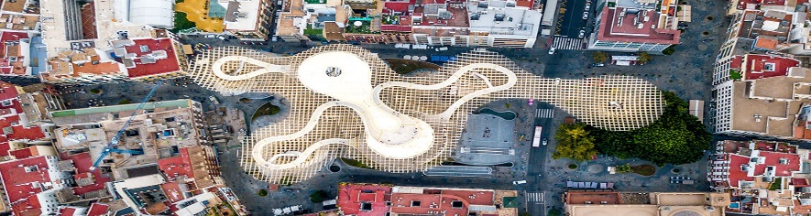
Gebäude „Casa de Pilatos“
Mit seinem Bau wurde Ende des 15. Jahrhunderts begonnen, und der Palast gilt als Urform des andalusischen Palastes.
Es vereint auf wunderbare Weise verschiedene architektonische Stile. Die Fassade ist im Renaissancestil gehalten und wird von gotischen Zinnen gekrönt. Der Haupthof weist Dekorationen im Mudéjar- und Platereskenstil auf. Im Ruheraum der Richter befindet sich ein schöner Bogen mit Mudejar- und Gotikelementen, einem schönen Kachelsockel und einem Stuckfries.

Gebäude „Casa de Pilatos
Plaza de Pilatos, 1
41003 Sevilla (Andalusien)
E-Mail:
taquilla@fundacionmedinaceli.org
casapilatos@fundacionmedinaceli.org
Tel.:+34 670 412 871
Tel.:+34 954 225 298
https://fundacionmedinaceli.org/monumentos/casa-de-pilatos/
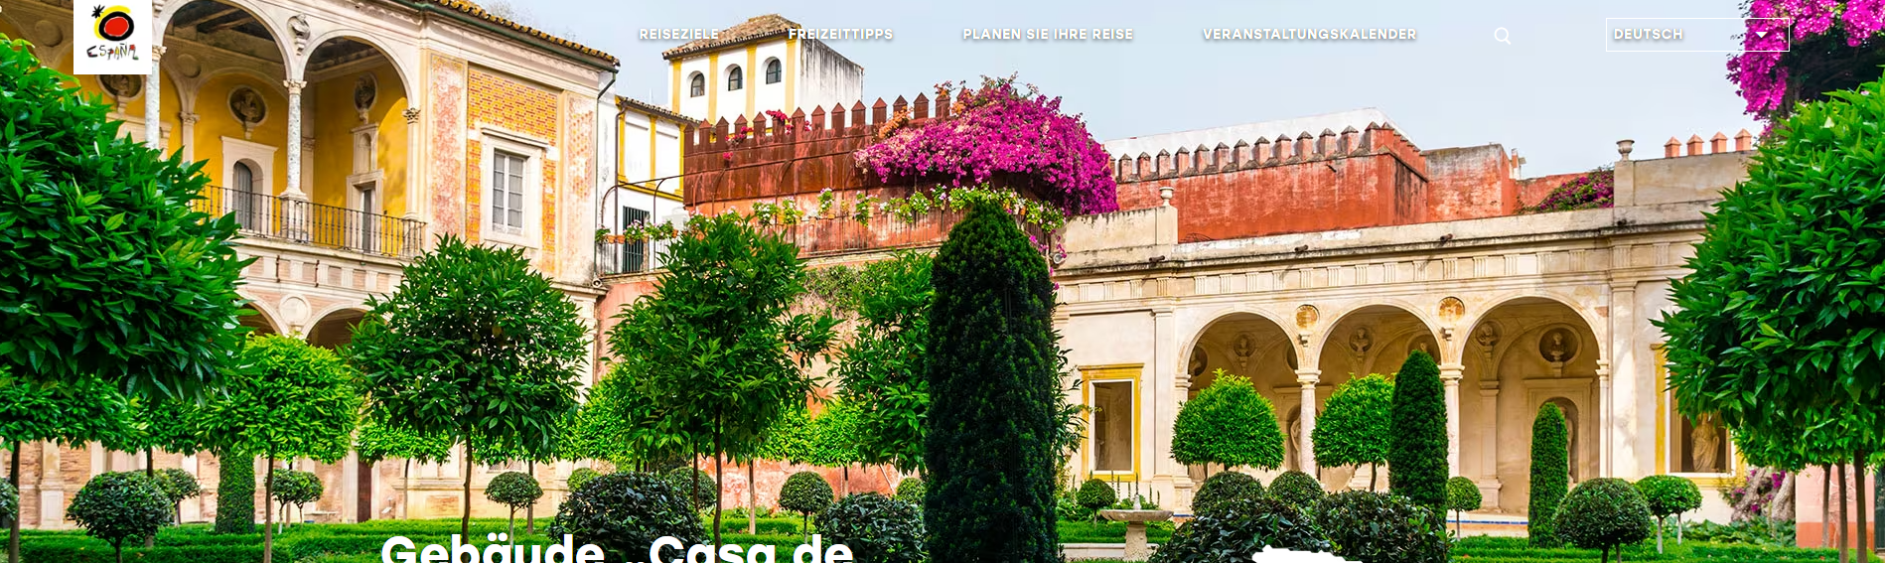

CORDOBA

06.10.2026 07.10.2026

Navigation to Cordoba

SEVILLA - CORDOBA
1 h 34 min (141 km)

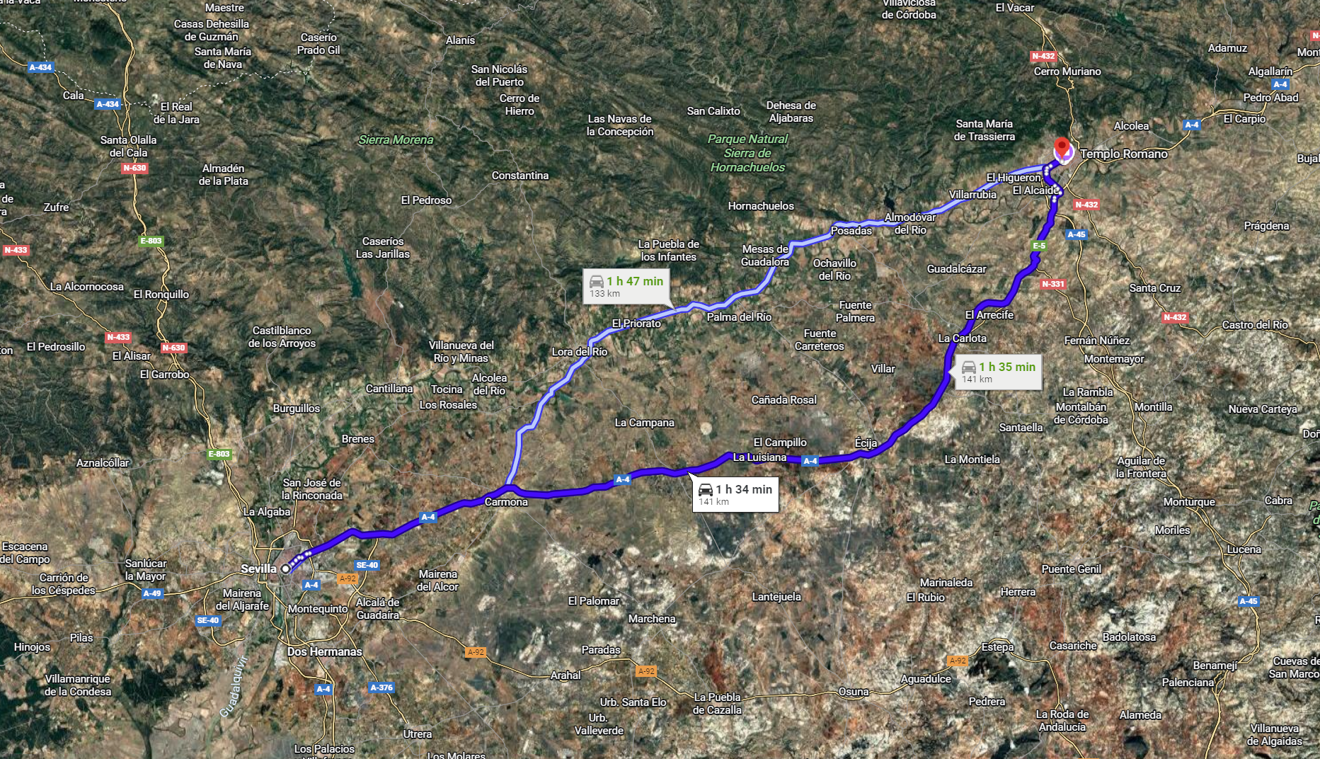

UNTERKUNFT CORDOBA
DATUM 06/10/2026 bis 08/10/2026
CORDOBA Hotel Posada de Vallina by MiRa
Corregidor Luis de la Cerda, 83, 14003 Córdoba
41003 Sevilla, Spanien
+34 957 49 87 50
http://www.hotelhaciendaposada.guestreservations.com
https://www.posadadevallina.es/

Lista e mappa Cordoba

- 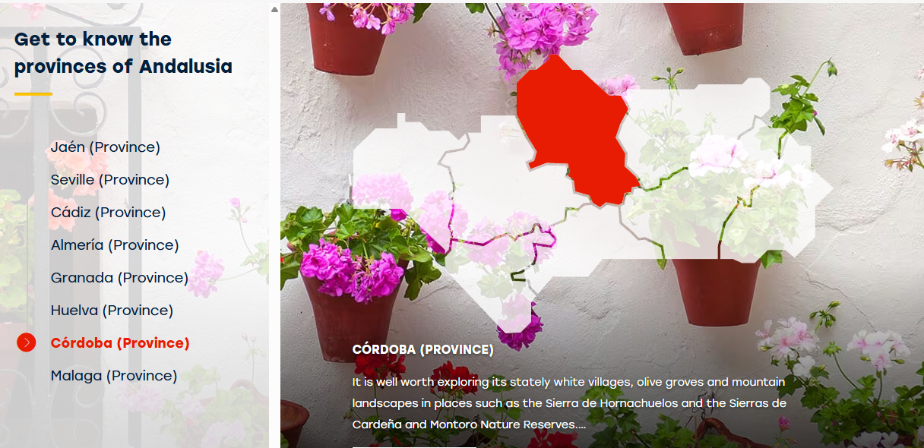

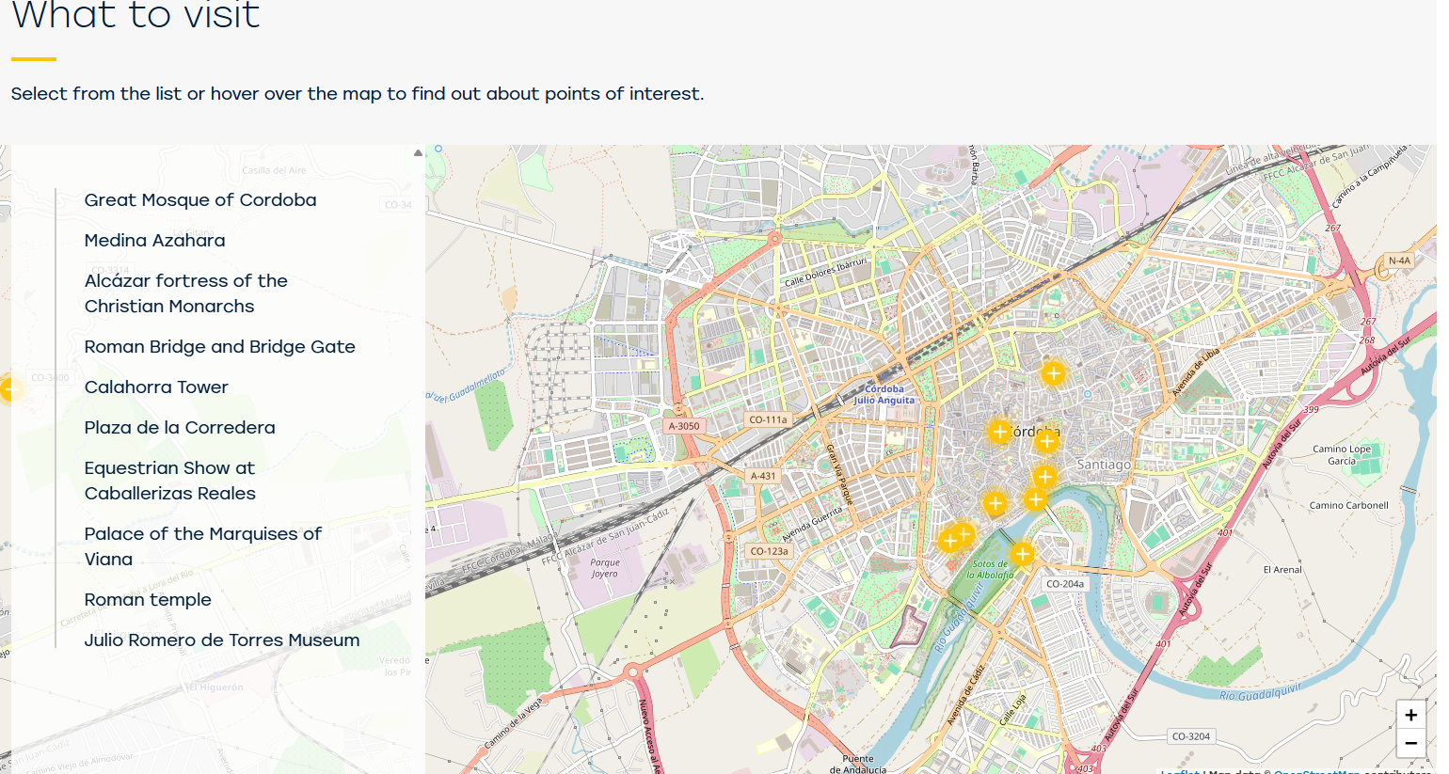
- Cordova: qui si trova la straordinaria Mezquita, una moschea-cattedrale unica al mondo, e le stradine fiorite del centro storico.

To visit in Cordoba

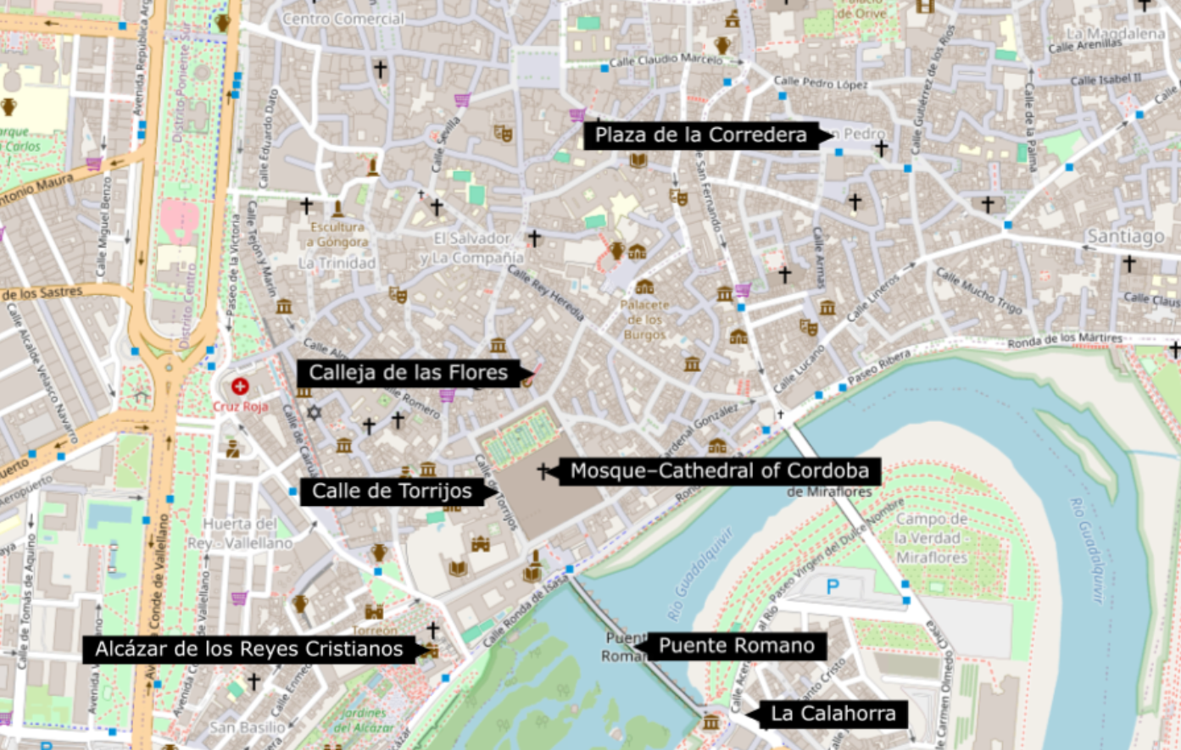

Medina Azahara
La città del califfato
Il califfo Abd al-Rahman III fu un grande promotore della cultura e un abile politico, che rese i suoi domini i più prosperi dell'epoca in Occidente, confrontabili solo a città come Bagdad e Bisanzio. La pianta di Medina Azahara è quasi rettangolare. Fu costruita su terrazze a gradoni sfruttando la morfologia della montagna. Ogni terrazza venne separata dalla successiva da muri, suddividendo la città in 3 parti. L'Alcazar Reale sorge su quella superiore e intermedia, mentre la zona più bassa, edificata fuori dalle mura, era destinata alle abitazioni e alla moschea. Attualmente si conservano resti di basamenti, pitture e colonne in stile composito e corinzio. Da non perdere la visita ai due saloni restaurati. È stato dichiarato Monumento Nazionale nel 1923.
Medina Azahara
Carretera de Palma del Río Km. 5,5
14071 Córdoba, Cordova (Andalusia)
madinatalzahra.ccul@juntadeandalucia.es
Tel.:+34 957 103 637
Tel.:+34 957 104 933
https://www.turismodecordoba.org/medina-azahara-1

Great Mosque of Cordoba
Calle Cardenal Herrero 1
14003 Córdoba, Cordoba (Andalusia)
informacion@mezquita-catedraldecordoba.es
Tel.:+34 957 470 512
https://mezquita-catedraldecordoba.es/
A different approach to this World Heritage monument.
It is an original way of exploring this unique mosque-cathedral. A nocturnal visit to discover the hidden secrets of the monument on a tour guided by light and accompanied by ambient sound. The visit takes place in groups and is available in the following languages: Spanish, English, French, German, Italian, Portuguese, Japanese and Arabic.
The Soul of Cordoba. Nocturnal
visit to the Great Mosque
September, Monday-Saturday, 9pm and 10.30pm.
October, Monday-Saturday, 8pm and 9.30pm.
November and December, Fridays and Saturdays, 8pm and 9.30pm.
* Information may be subject to modifications
  - General: €18
  - Reduced: €9
* Information may be subject to modifications
Mezquita- Catedral de Córdoba

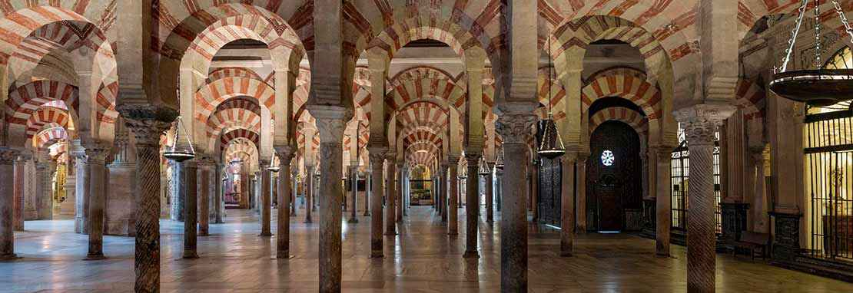

Roman Bridge and Bridge Gate
This bridge connecting the city with Calahorra Tower is believed to have been built in the era of Augustus.
In 918 it underwent major changes. It played an important role in the city's battles against the armies of Peter I, the Cruel. It has 16 arches supported by robust spurs with semi cylindrical buttresses. It is built in Flemish bond. In the centre there is a sculpture of San Rafael from 1651.
Ronda de Isasa s/n
14003 Córdoba, Cordoba (Andalusia)
Email:informacion@turismodecordoba.org
Tel.:+34 957 469 707 (Turismo de Córdoba)
Tel.:+34 957 471 577
https://www.turismodecordoba.org/the-gate-of-the-bridge
https://www.turismodecordoba.org/puente-romano-roman-bridge

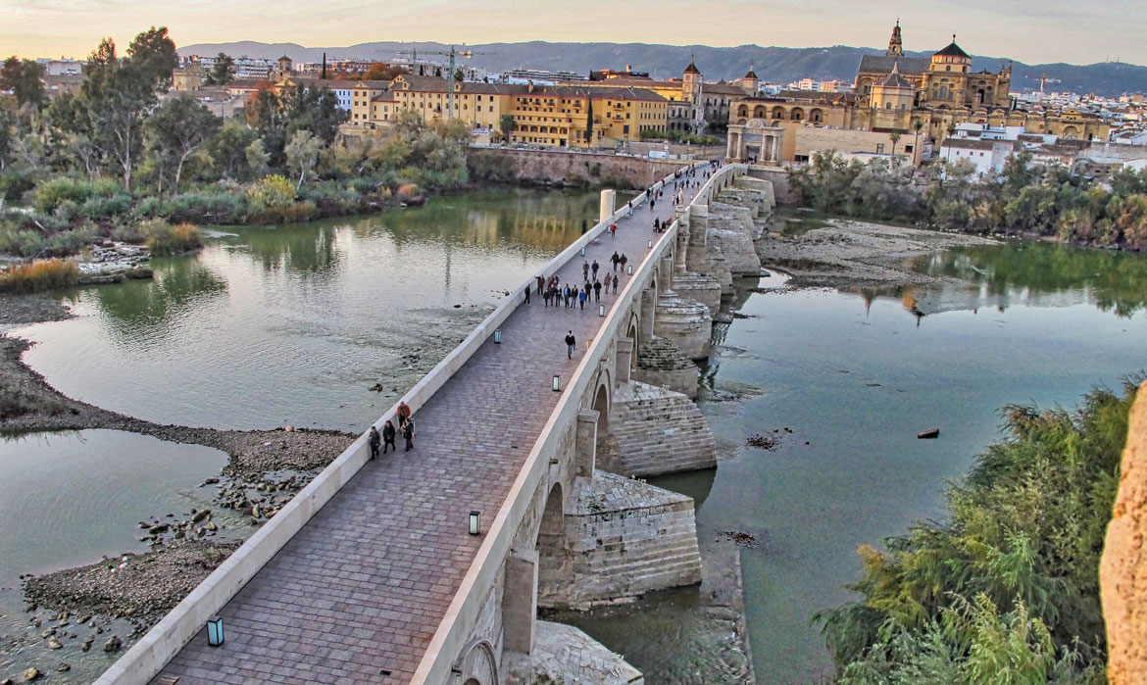

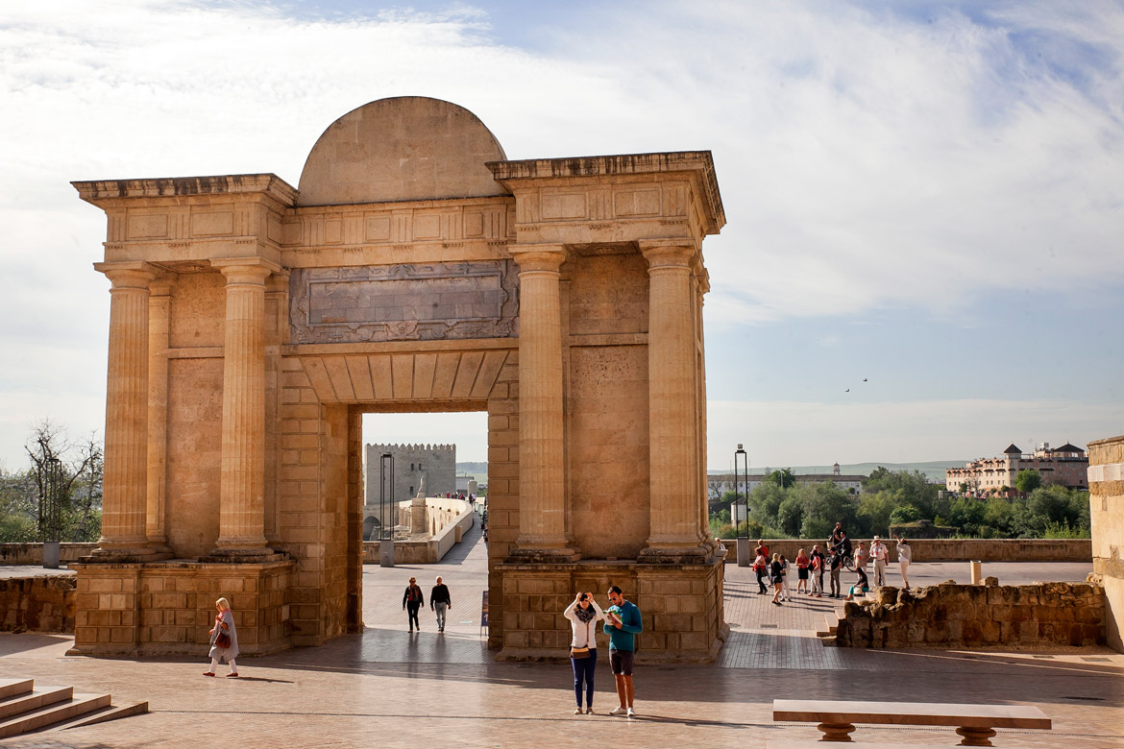
***TEMPORARILY CLOSED***
This gate originally formed part of the city walls, but from the Christian conquest onwards it became a gateway, known then as the Algeciras Gate, where the road leading south out of Cordoba started from. In the 14th Century, Hernán Ruiz III redesigned the gate to mark the visit of Philip II to the city, and gave it the grand, monumental style which survives to this day. It is made up of three sections, with fluted columns at each end, and the centre opening topped with a lintel and a curved pediment. At the turn of the 20th century, the surrounding buildings were cleared away and the ground was lowered to restore it to its original height.
Nowadays, The Gate of the Bridge is open to the public. The visit includes admission to the permanent Exhibition Room, illustrating the history of the Gate in words and pictures, as well as access to the balcony on the top floor, which affords excellent views of all the other

Alcázar fortress of the Christian Monarchs
The residence of Ferdinand and Isabella
Calle Caballerizas Reales, s/n
14004 Córdoba, Cordoba (Andalusia)
museos@ayuncordoba.es
Tel.:+34 957 420 151
https://www.turismodecordoba.org/castle-of-the-christian-monarchs
https://alcazardelosreyescristianos.cordoba.es

The Catholic Monarchs reigned from this palace-fortress for eight years.
This building was the royal residence of the Christian monarchs and subsequently the site of the Courts of the Holy Offices, a civil prison, and finally a military prison. It is set among magnificent gardens, including the garden known as the Avenue of the Monarchs which features statues of all the monarchs who had connections with the palace-fortress. It was declared a Historical Monument in 1931. The building is also part of the area declared a World Heritage site by UNESCO in 1994. Since 1986, its gardens have been protected by town planning laws. It stands on top of the remains of the former caliph's palace.
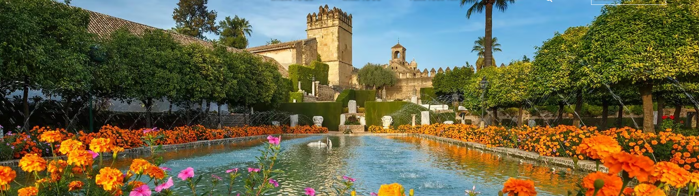

Festungsturm La Calahorra
Sie wurde von Enrique II de Trastámara gebaut um sich vor den Angriffen seines Bruders, Pedro I el Cruel (dem Grausamen), zu schützen. Ihr Standort war früher der einer arabischen Burg.
Sie hat die Form eines lateinischen Kreuzes mit drei Armen, die von quadratischen Türmen gebildet werden, die durch zylinderförmige Räume miteinander verbunden sind und von Zinnen abgeschlossen werden. Sie liegt an den Ufern der römischen Brücke und war Zeuge zahlreicher Kämpfe. Sitz des Lebendigen Museums von Al-Andalus (Stiftung Paradigma Cordoba).
Festungsturm La Calahorra
Puente Romano, s/n
14009 Córdoba (Andalusien)
torrecalahorra@torrecalahorra.com
Tel.:+34 957 293 929
https://www.torrecalahorra.es/
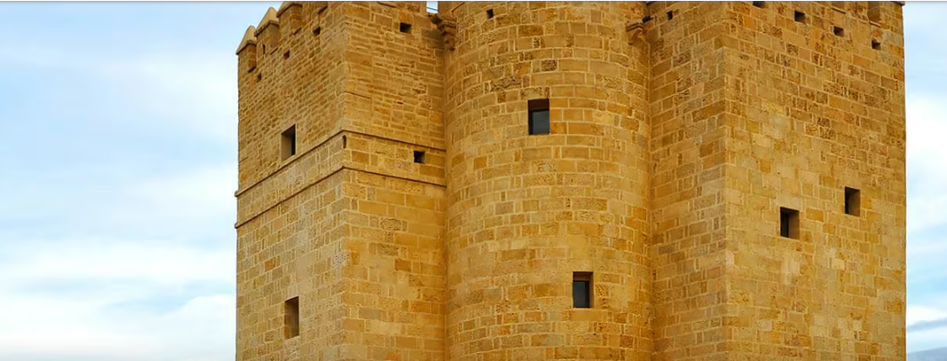

Lebendiges Museum von Al-Andalus – Turm von Calahorra
Dieses Museum befindet sich in einer alten muslimischen Festung und lässt die glanzvollen Zeiten dieser Stadt in Andalusien wieder aufleben.
Das Museum wurde im Calahorra-Turm gegenüber der Moschee am Ende der Römischen Brücke eingerichtet. Damit soll die cordobesische Epoche des 9. bis 13. Jahrhunderts heraufbeschworen werden, eine Zeit der kulturellen, künstlerischen und wissenschaftlichen Blüte. Zu den modernen Einrichtungen gehört auch ein System mit Kopfhörern und Infrarotstrahlen, das den Besucher durch die acht thematischen Säle mit Dioramen führt.

Lebendiges Museum von Al-Andalus – Turm von Calahorra
Puente Romano s/n
14009 Córdoba (Andalusien)
torrecalahorra@torrecalahorra.com
Tel.:+34 957293929
www.torrecalahorra.es

Kathedrale von Córdoba
Es ist eine Mischung aus sich überlagernden Baustilen, die sich im Laufe von neun Jahrhunderten Bau- und Renovierungsarbeiten abwechselten.
Die Moschee-Kathedrale von Córdoba, die sich im historischen Zentrum der Stadt befindet, ist eines der schönsten Beispiele muslimischer Kunst in Spanien.
Die Errichtung dieses Tempels auf den Resten der ehemaligen westgotischen San Vicente-Kirche wurde vom maurischen Emir Abd ar-Rahman I. im Jahr 785 angeordnet. In den darauffolgenden Jahrhunderten wurde die Moschee mehrfach erweitert. Abd ar-Rahman III. ließ ein neues Minarett errichten, im Jahr 961 ließ Al-Hakam II. den Grundriss des Gebäudes vergrößern und die Mihrab verzieren. Die letzte Reform wurde von Almanzor im Jahre 987 durchgeführt. Das Ergebnis ist ein wunderschönes Säulenlabyrinth mit Doppel- und Hufeisenbögen im Inneren. Nach der Reconquista durch die Christen wurde im Jahr 1523 im Inneren eine Kathedrale errichtet, in der sich unter anderem das Retabel des Hauptaltars, das barocke Retabel und das Chorgestühl aus Kaobaholz bewundern lassen. Der Mihrab ist einer der wichtigsten in der muslimischen Welt und der edelste Teil der Moschee-Kathedrale. Sie ist mit byzantiner Mosaiken und geschliffenem Marmor verziert. Eingang zum Gelände ist der Patio de los Naranjos.
Kathedrale von Córdoba
Calle Cardenal Herrero 1
14003 Córdoba (Andalusien)
informacion@mezquita-catedraldecordoba.es
Tel.:+34 957 470 512
https://mezquita-catedraldecordoba.es

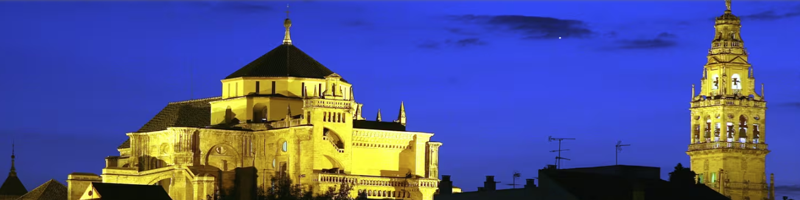

Plaza de la Corredera
Mit seiner rechteckigen Form folgt er dem Modell des Plaza Mayor im kastilischen Stil und ist der einzige seiner Art in Andalusien. Bei den Umbauarbeiten wurden prächtige Mosaike aus der Römerzeit gefunden, die im Alcázar de los Reyes Cristianos zu sehen sind. Plaza de la Corredera
14002 Córdoba (Andalusien)
informacion@turismodecordoba.org
Tel.:+34 957 469 707 (Turismo de Córdoba)
https://www.turismodecordoba.org/plaza-de-la-corredera

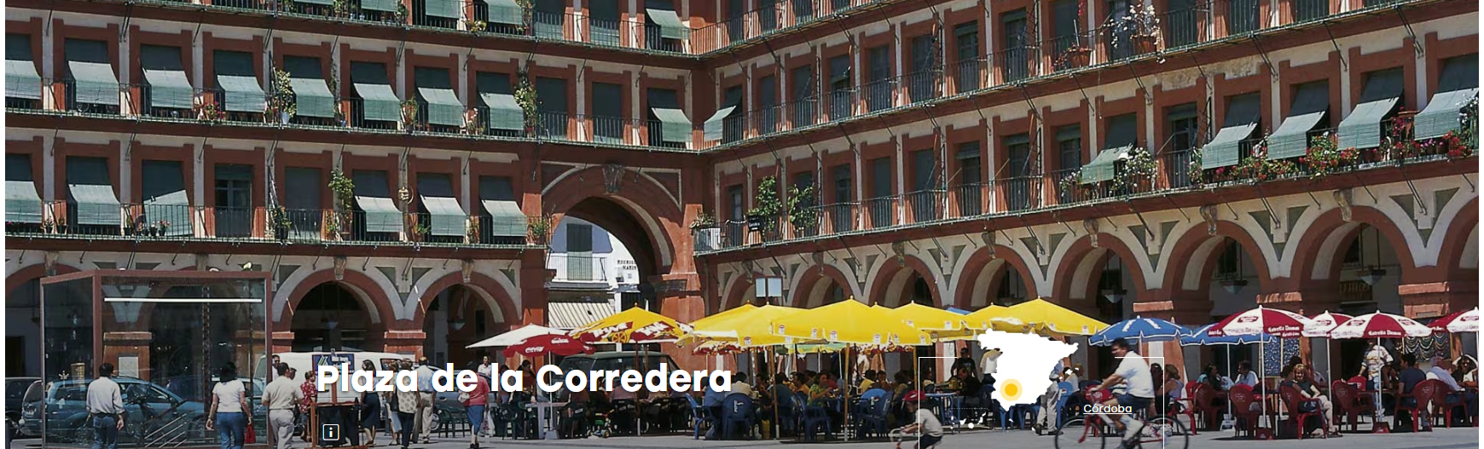

Calleja de las Flores
Das Wesen Córdobas.
Die Straße liegt mitten im Judenviertel und von hier aus sieht man den Turm der Kathedrale.
Es ist eine Sackgasse gegenüber der der Nordfassade der Moschee, die auf einem Platz endet, von dem aus man einen großartigen Blick auf den Turm der Kathedrale hat. Es ist eine typische andalusische Straße mit weiß getünchten Häusern und blumengeschmückten Balkons.
Calleja de las Flores
14003 Córdoba (Andalusien)
informacion@turismodecordoba.org
Tel.:+34 957 469 707 (Turismo de Córdoba)
https://www.turismodecordoba.org/calleja-de-las-flores-alley-of-the-flowers
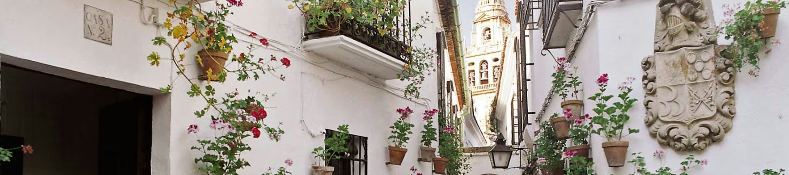

Archäologisches Museum von Cordoba
Begegnung der Kulturen

Das Archäologische Museum von Córdoba besitzt eine sehr umfangreiche Sammlung, die von der Vorgeschichte bis zum Mittelalter reicht.
Es verfügt über eine bedeutende Sammlung zur lokalen Vorgeschichte und Archäologie, die Elemente der iberischen, römischen und westgotischen Kultur umfasst. Interessant sind auch die Exponate aus den Epochen Islam, Mudejar, Gotik und Renaissance. Von besonderem historischen und künstlerischen Wert sind der iberische Löwe von Nueva Carteya und die römische Skulptur des Gottes Mithra.Bei den Erweiterungsarbeiten des Museums wurde das größte Theater des römischen Hispaniens freigelegt, das Teil der Besichtigung ist.

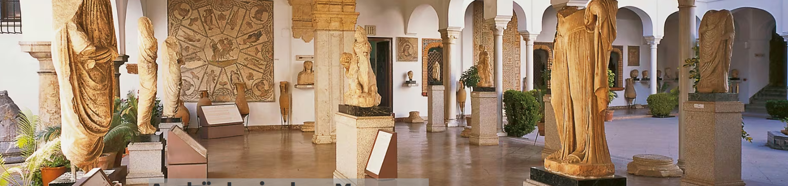

Archäologisches Museum von Cordoba
Plaza Jerónimo Páez, 7
14003 Córdoba (Andalusien)
museoarqueologicocordoba.ccul@juntadeandalucia.es
Tel.:+34 957355517Tel.:+34 957355525
https://www.turismodecordoba.org/museo-arqueologico-de-cordoba

Römischer Tempel
Die Reste dieses Tempels befinden sich neben dem Rathaus. Aus den noch vorhandenen Fundstücken lässt sich schließen, dass er enorm groß gewesen sein muss.
Er war den mythologischen Göttern gewidmet und befindet sich mitten auf einem großen, von Säulen umgebenen Platz. Der Tempel war einem sehr hohen Podium errichtet, auf das sich korintische Säulen stützten. Er wurde unter dem römischen Kaiser Claudius (aus der julisch-claudischen Dynastie) errichtet, jedoch erst unter Kaiser Domitian (aus der flavischen Dynastie) fertiggestellt.
Römischer Tempel

Calle Capitulares, 1
14002 Córdoba (Andalusien)
informacion@turismodecordoba.org
Tel.:+34 957 469 707 (Turismo de Córdoba)
https://www.turismodecordoba.org/roman-temple
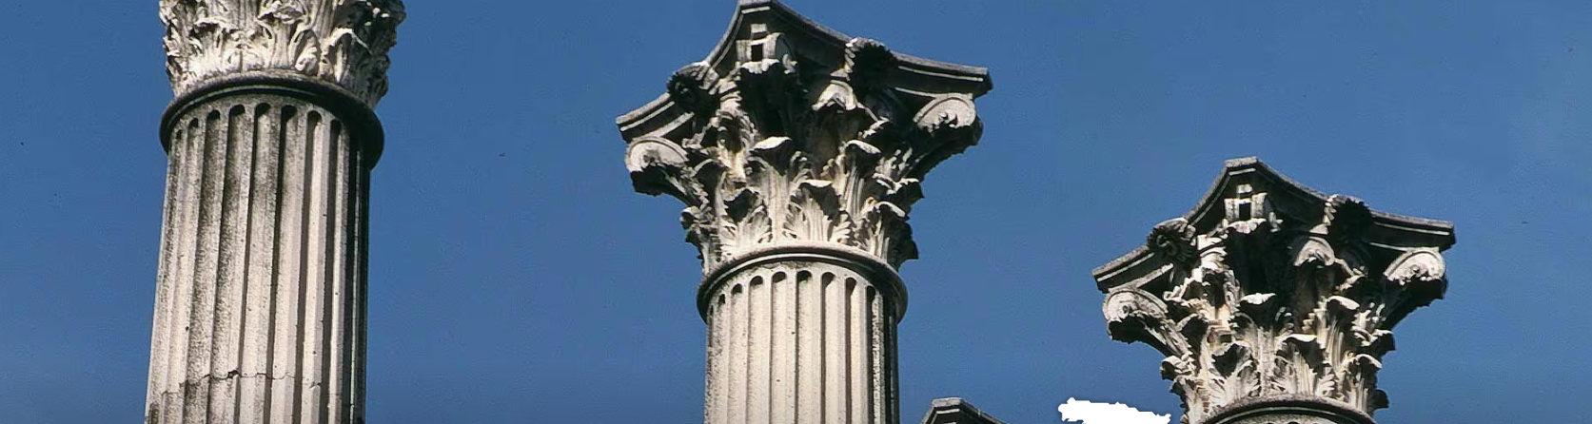

Museum „Julio Romero de Torres”

Das Córdoba von Romero de Torres
Dieses Museum zeigt einen Teil des Werks sowie die persönlichen Gegenstände des Malers Julio Romero de Torres.
Die Ausstellung widmet sich ausschließlich dem aus Córdoba stammenden Maler Julio Romero de Torres. Seit 1931 birgt das Museum wertvolle Bilder des Künstlers, die seine Liebe zu seiner Stadt zum Ausdruck bringen. Neben den Gemälden sind auch die Möbel, Paletten und Pinsel des Künstlers sowie seine Bibliothek zu sehen.
Museum „Julio Romero de Torres”
Plaza del Potro 1
14002 Córdoba (Andalusien)
museos@ayuncordoba.es
Tel.:+34 957 760 269
Tel.:+34 957 470 356
https://museojulioromero.cordoba.es/index.php?id=1

Equestrian Show at Caballerizas Reales
Equestrian Show at Caballerizas Reales
Royal Stables
C/ Caballerizas Reales, 1
Córdoba, Cordoba (Andalusia)
www.cordobaecuestre.com
Wednesday, Thursday, Friday, Saturday 9:00 p.m. (times subject to seasonal changes)
* Information may be subject to modifications
- Adults: €16.50
- Children (3-12 years): €11.50
- Premium: €22.70

GRANADA
Cordoba – Granada

09.10.2026

Navigation to Granada

CORDOBA - GRANADA
2 h 35 min (205 km)

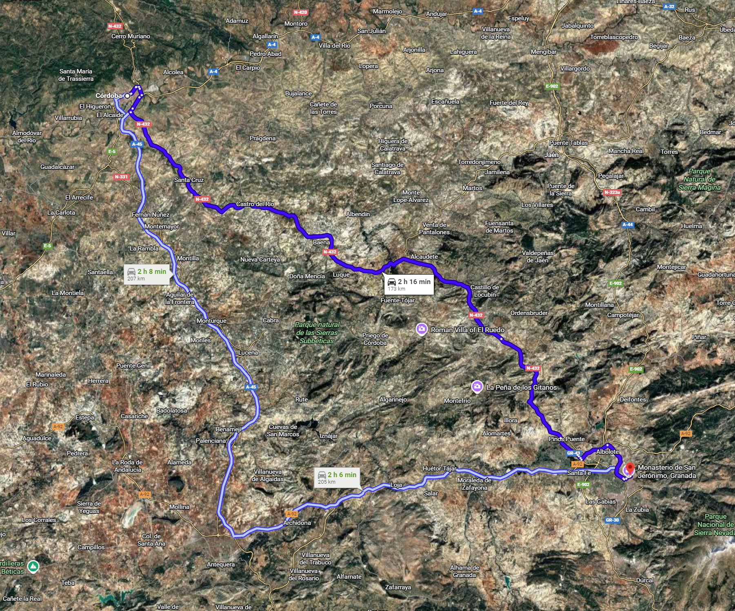

UNTERKUNFT GRANADA
DATUM 08/10/2026 bis 9/10/2026
GRANADA Hotel Anacapri
Joaquín Costa, 7, Stadtzentrum, 18010 Granada
18010 GRANADA,
+34 958 227 477
https://hotelanacapri.com

Anreise mit dem Auto
Von der Autobahn kommend, nehmen Sie die Ausfahrt 13 Richtung CENTRO/RECOGIDAS.
Folgen Sie der Recogidas-Straße geradeaus bis zur Puerta Real und fahren Sie weiter auf der Ángel-Ganivet-Straße, wobei Sie das Postgebäude zu Ihrer Rechten lassen. Fahren Sie weiter bis zum Mariana-Pineda-Platz; links vom Platz gehen Sie die San-Matías-Straße hinauf bis zum Ende und biegen dann links ab, um zum Isabel-la-Católica-Platz zu gelangen. Fahren Sie geradeaus die Gran Vía de Colón entlang und biegen Sie dann an der ersten Straße, der Almireceros-Straße, rechts ab.
Biegen Sie anschließend rechts in die Joaquín Costa Straße ein, bis Sie das Hotel finden. Am Hoteleingang gibt es einen separaten Bereich zum Be- und Entladen von Gepäck. An der Rezeption erläutern wir Ihnen die Möglichkeiten für Partnerparkplätze mit Sonderpreisen für unsere Kunden.
Die Stadtverwaltung Granada hat unseren Gästen eine Sonderzufahrt zum Hotel Anacapri gewährt. Um mögliche Bußgelder zu vermeiden , teilen Sie uns bitte vor Ihrer Ankunft Ihr Kfz- Kennzeichen sowie den Namen und die Ausweisnummer des Fahrzeughalters mit . Wir übermitteln der Verkehrsbehörde der Stadt Granada täglich eine Liste der Kfz-Kennzeichen unserer Hotelgäste, um ihnen die Nutzung dieser Zufahrtsstraße zu ermöglichen.
Bitte seien Sie besonders vorsichtig mit dem Poller in der Elvira Street. Sie müssen den Knopf drücken und signalisieren, dass Sie in Richtung Hotel Anacapri fahren, damit die Verkehrspolizisten den Poller absenken können. Achten Sie darauf, keinem anderen Fahrzeug zu folgen, da sich der Poller bereits nach der Durchfahrt eines einzigen Fahrzeugs wieder aktiviert.
Um Probleme mit dem Poller zu vermeiden, fahren Sie bitte über die in diesem Abschnitt empfohlene Route zum Hotel .

Lista e mappa Granada

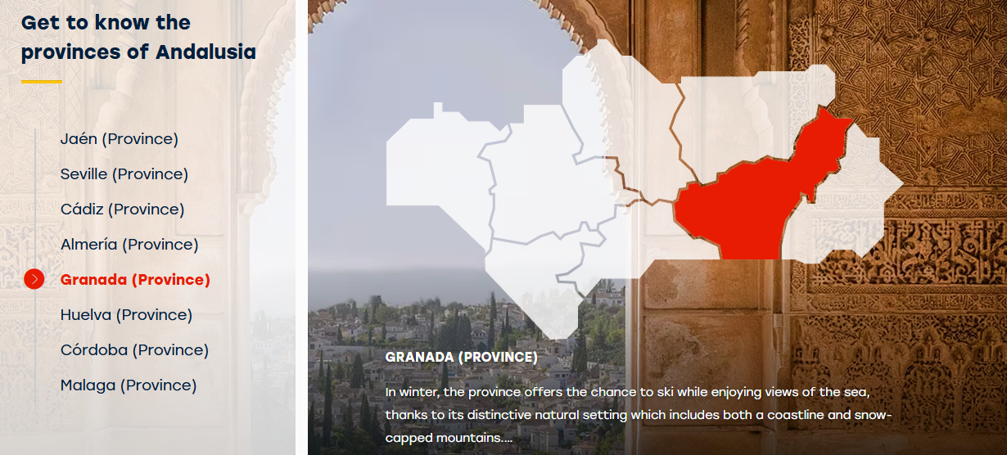

- Granada: celebre per l’Alhambra, un gioiello dell’architettura moresca, e il quartiere dell’Albaicín, Patrimonio UNESCO.

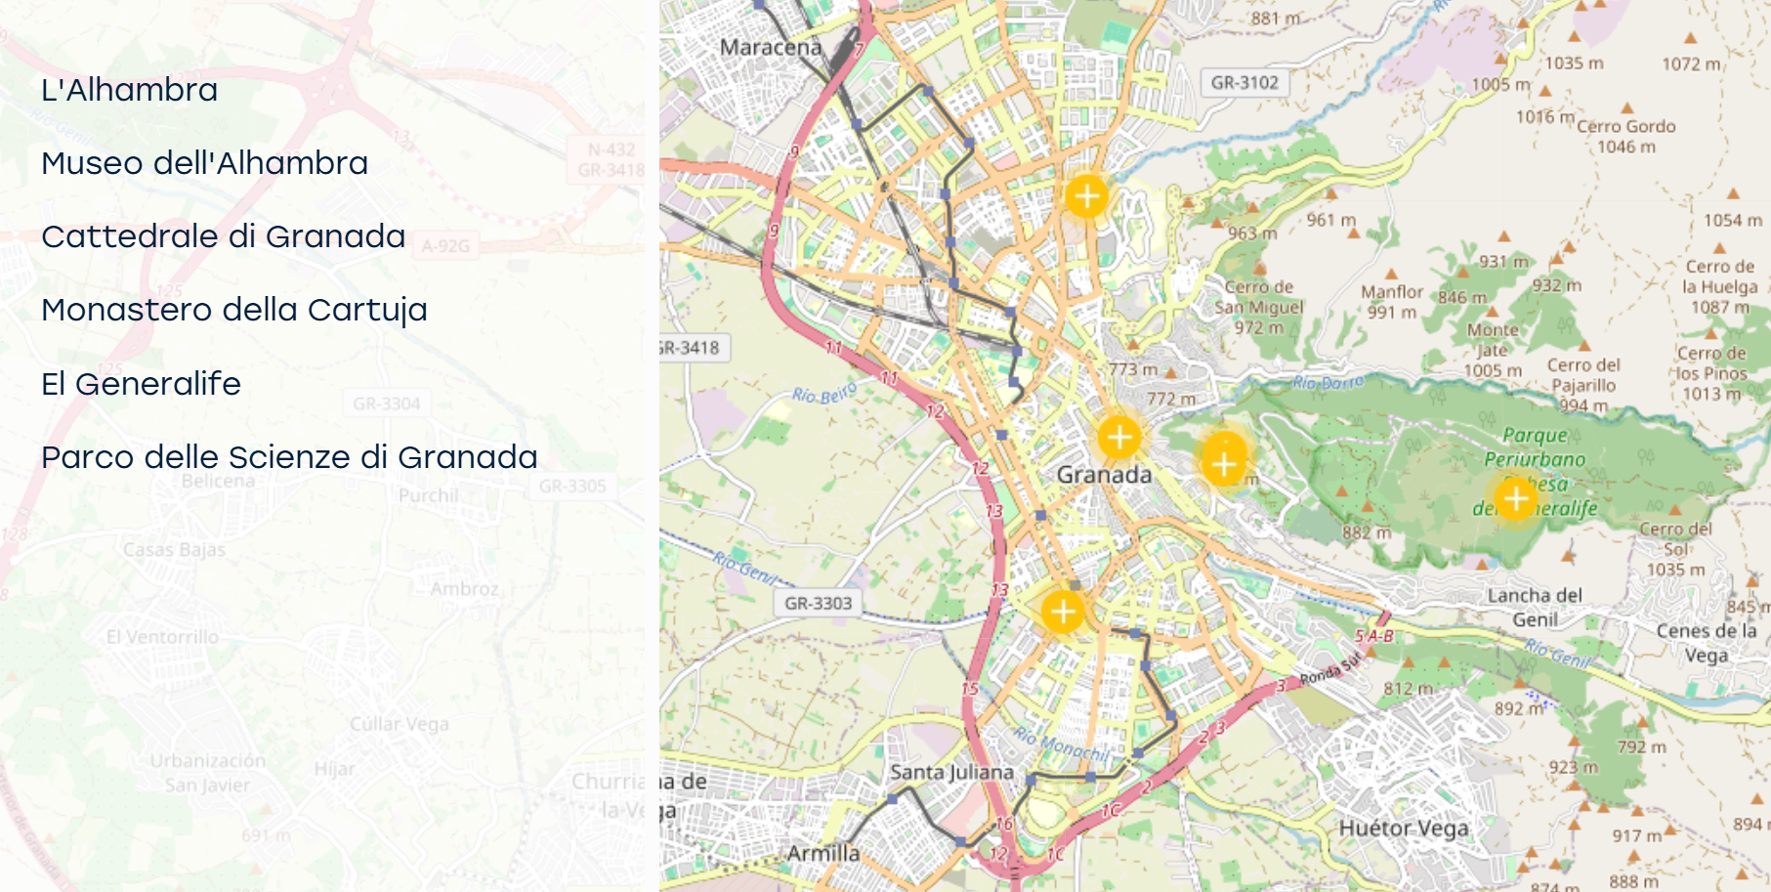

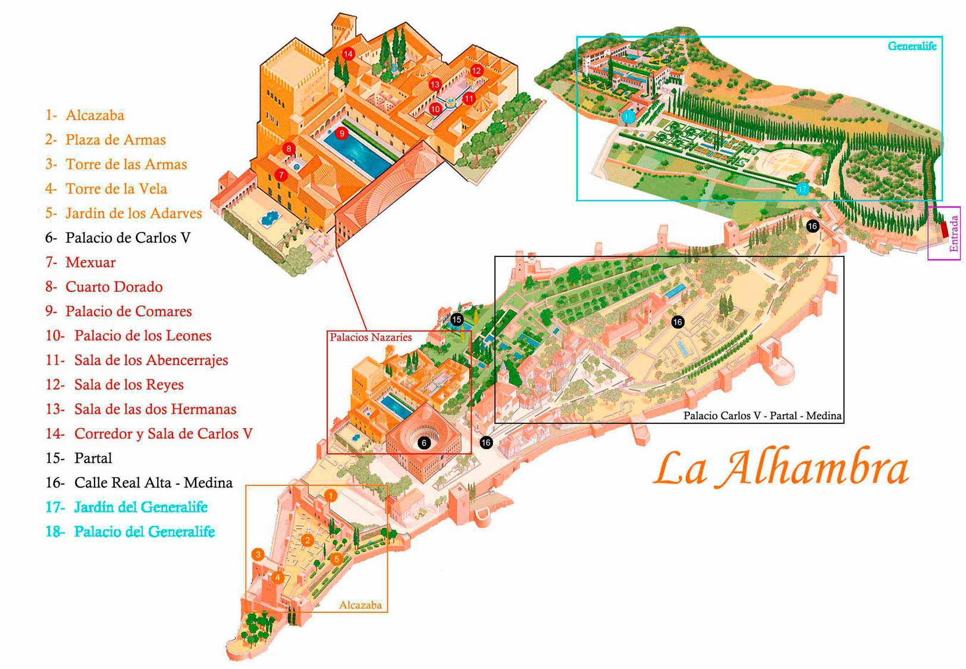

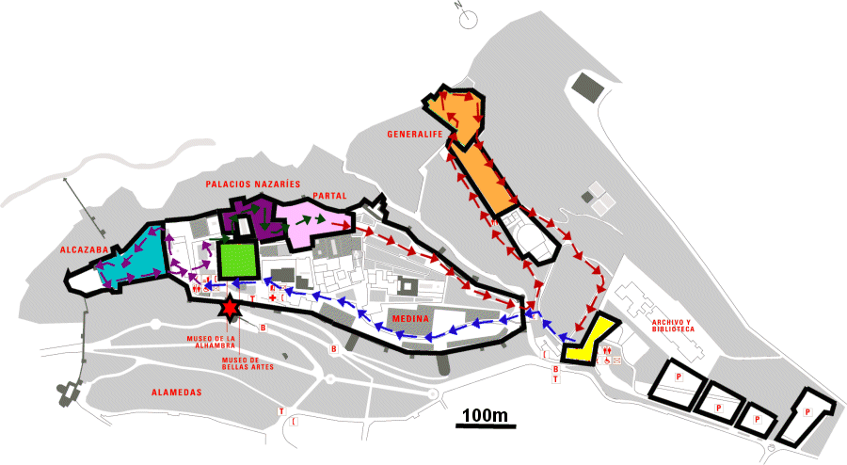

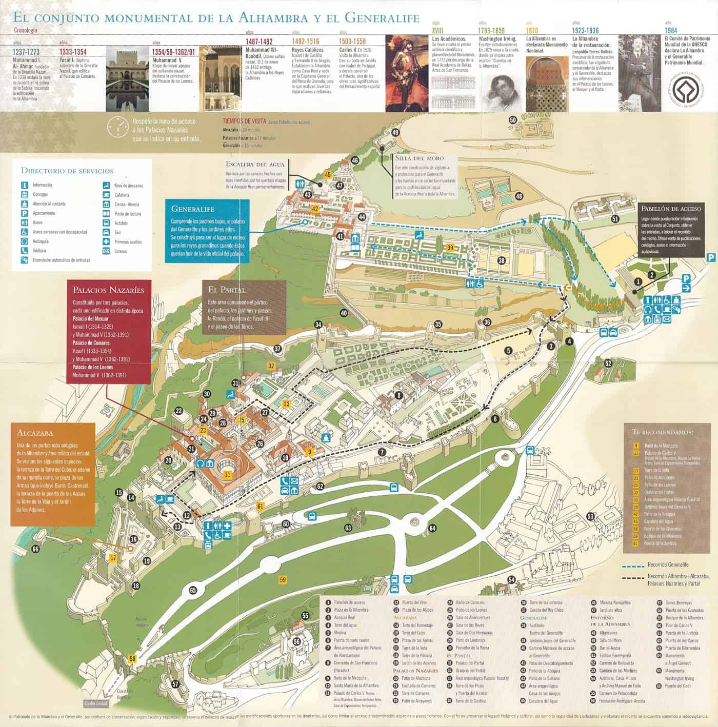

To visit in Granada

Alhambra
L'Alhambra è un bel complesso di edifici e giardini. Gli alberi frondosi che popolano i suoi viali offrono un'ombra gradevole e una freschezza accresciuta dall'abbondanza delle acque che scorrono lungo i ruscelli.
Principale centro politico e aristocratico dell'occidente musulmano, il complesso dell'Alhambra è formato da cortili rettangolari di grande bellezza, con numerose fontane, ed edifici in stile Nazarí che davano dimora a sovrani e servitù. L'edificio più antico è l'Alcazaba. Una delle costruzioni più importanti è la torre della Vela, dalla quale si gode di una delle vedute più belle dell'Alhambra. Il cortile dei Leoni e la sua fontana sono tra i più belli del complesso.
L'Alhambra
Calle Real de la Alhambra, s/n.
18009 Granada (Andalusia)
Tel.:+34 958 027 971
https://www.alhambra-patronato.es/en
Tel. prenotazioni:+34 858 889 002

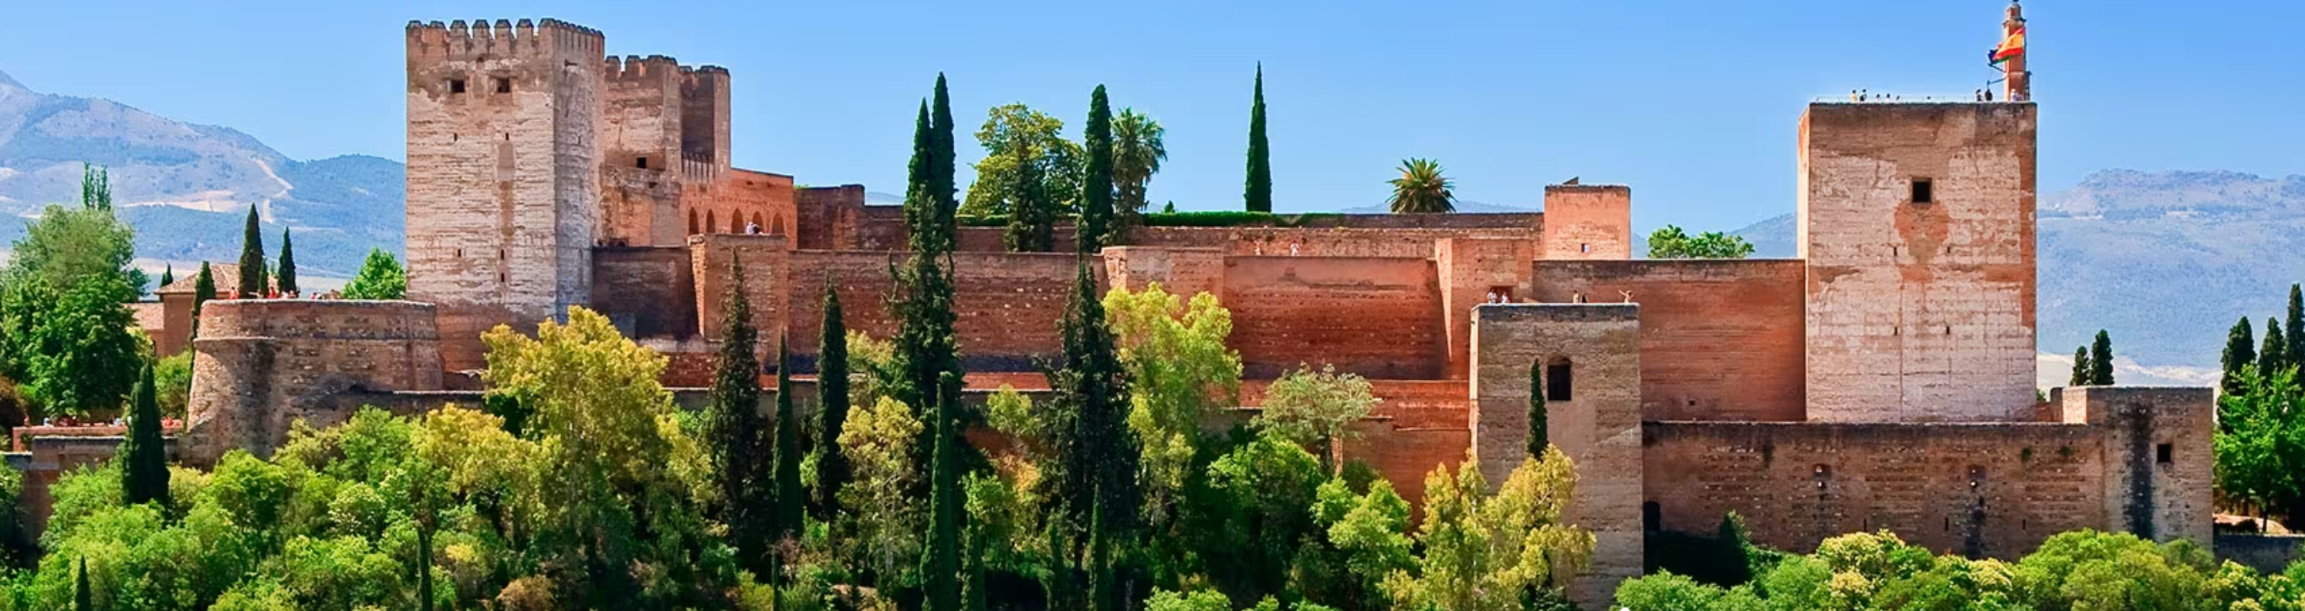

Museo dell'Alhambra
Sulla cultura ispano-musulmana
Si trova nel Palazzo di Carlo V, situato nel complesso monumentale dell'Alhambra ma con accesso libero. Ospita una brillante rappresentazione della civiltà ispano-musulmana e dell'arte califfale e nasride.
È dedicato alla cultura e all'arte ispano-musulmana. Custodisce numerose testimonianze archeologiche raccolte nell'Alhambra o in scavi esterni ad essa correlati. In questo centro si possono trovare esempi rappresentativi della religione, della scienza e dell'economia islamica, nonché oggetti dei primi anni della presenza musulmana nella penisola iberica, differenziando il periodo emiraziale e quello califfale. Particolarmente belli sono i rivestimenti in gesso delle pareti, i soffitti di legno e le stoviglie domestiche.
Museo dell'Alhambra
Palacio de Carlos V, Alhambra
18009 Granada (Andalusia)
oficina@alhambra.org
Tel.:+34 958 027 931
Tel.:+34 958 027 929
https://www.alhambra.org/museos-alhambra.html

Cattedrale di Granada
Chiesa rinascimentale
Diego de Siloé trovò la soluzione perfetta per collegare una cupola rinascimentale ad una struttura gotica. Unì la pianta circolare con quella basilicale, ottenendo per questo il riconoscimento degli architetti dell’epoca.
La cappella maggiore sintetizza la grandezza di questo edificio. La sua cupola è decorata con vetrate di grande bellezza, insieme a sculture e dipinti di Alonso Cano. Presenta tre porte particolarmente belle: quella dell’Ecce Homo, quella di San Jerónimo e quella del Perdono, quest’ultima con eccellenti bassorilievi raffiguranti la Fede e la Giustizia. La facciata principale è barocca. Gli stalli del coro sono in stile plateresco Nelle cappelle laterali si conservano pale d’altare e pitture notevoli. Attualmente l’antica sala capitolare è il luogo di esposizione del tesoro della cattedrale, i cui fondi sono custoditi anche nella sacrestia e nel museo cattedralizio. Da segnalare l’Immacolata di Alonso Cano.
Cattedrale di Granada
Gran Vía de Colón, 5
18001 Granada (Andalusia)
info@catedraldegranada.com
visitacultural@catedraldegranada.com
Tel.:+34 958 222 959
www.catedraldegranada.com

Monastero della Cartuja
Il barocco di Granada.
Sebbene il progetto risalga al medioevo, lo stile è totalmente barocco.
Fu costruita solo nel 1515, allontanandosi dall’austero progetto iniziale per integrare nella chiesa la sagrestia e il sacrario, opera di artisti diversi, conformando un complesso che rappresenta la massima espressione del barocco andaluso. La sagrestia è considerata di fatto un capolavoro del tardo barocco spagnolo. Nella ricca decorazione interna spiccano elementi ornamentali come i marmi, le colonne, le sculture in legno e le incrostazioni in materiali differenti. Custodisce una preziosa collezione di dipinti di artisti come Sánchez Cotán e Bocanegra.
Monastero della Cartuja
Paseo de la Cartuja, s/n.
18011 Granada (Andalusia)
Tel.:+34 958 161 932
info@cartujadegranada.com
visitascartuja@archidiocesisgranada.es
http://www.archidiocesisgranada.es/index.php/patrimonio-cultural/la-cartuja
https://cartujadegranada.com/

El Generalife
Il giardino reale.
Era la residenza di campagna del sultano, l'orto per l'approvvigionamento dei palazzi e la zona di svago della nobiltà.
L'effetto di ricca vegetazione si ottenne deviando, mediante canali, il corso del fiume Darro fino al Generalife. Il Cortile dell'Acequia è di grande bellezza e colore e funge da ingresso al palazzo. L'edificio è composto da due corpi posti alle estremità di un grande cortile con una vasca al centro. Su un versante della Collina del Sol si trova il cortile del Generalife, costruito tra il XIII e il XIV secolo e dedicato allo svago. Da qui si possono ammirare vedute straordinarie.
El Generalife
Paseo del Generalife, s/n.
18009 Granada (Andalusia)
informacion.alhambra.pag@juntadeandalucia.es
Tel.:+34 958 027 971
www.alhambra-patronato.es
Tel. prenotazioni:+34 858 889 002
https://www.alhambra-patronato.es/en/espacio/gardens

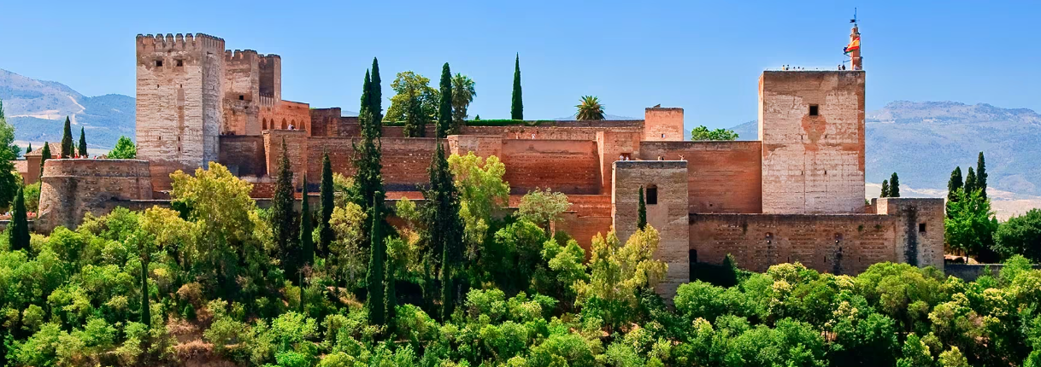

Granada Parque de las Ciencias

The world we live in
The Science Park is a 70,000-square-metre interactive museum that encourages visitor engagement in order to understand phenomena of the environment such as inertia, gravity and the Archimedes' principle. It has established itself as a true international reference centre.
The park includes spaces such as seven permanent exhibition pavilions, another 5,000 square metres for temporary exhibitions, the digital planetarium, the cinemas, the auditorium, the cultural gallery, the library and the Windows to Science. The topics addressed are, for example, health, the environment, architecture, literature, physics, chemistry, mechanics, astronomy and the scientific legacy of Andalusian culture.At the same time, its 27,000 square metres of green spaces create an open-air museum, with exhibition spaces such as the observation tower, the “raptors in flight” workshop, the tropical butterfly house, the astronomical observatory, the astronomy garden, the botanical tours, the plant labyrinth and the mental gymnastics tent.
Granada Parque de las Ciencias
Avenida de la Ciencia, s/n (accesi por el edificio Macroscopio)
18006 Granada (Andalusia)
info@parqueciencias.comTel.:+34 958 131 900
https://www.parqueciencias.com/

Málaga

10.10.2026

Navigation to Malaga

GRANADA - MALAGA
1 h 57 min (150 km)
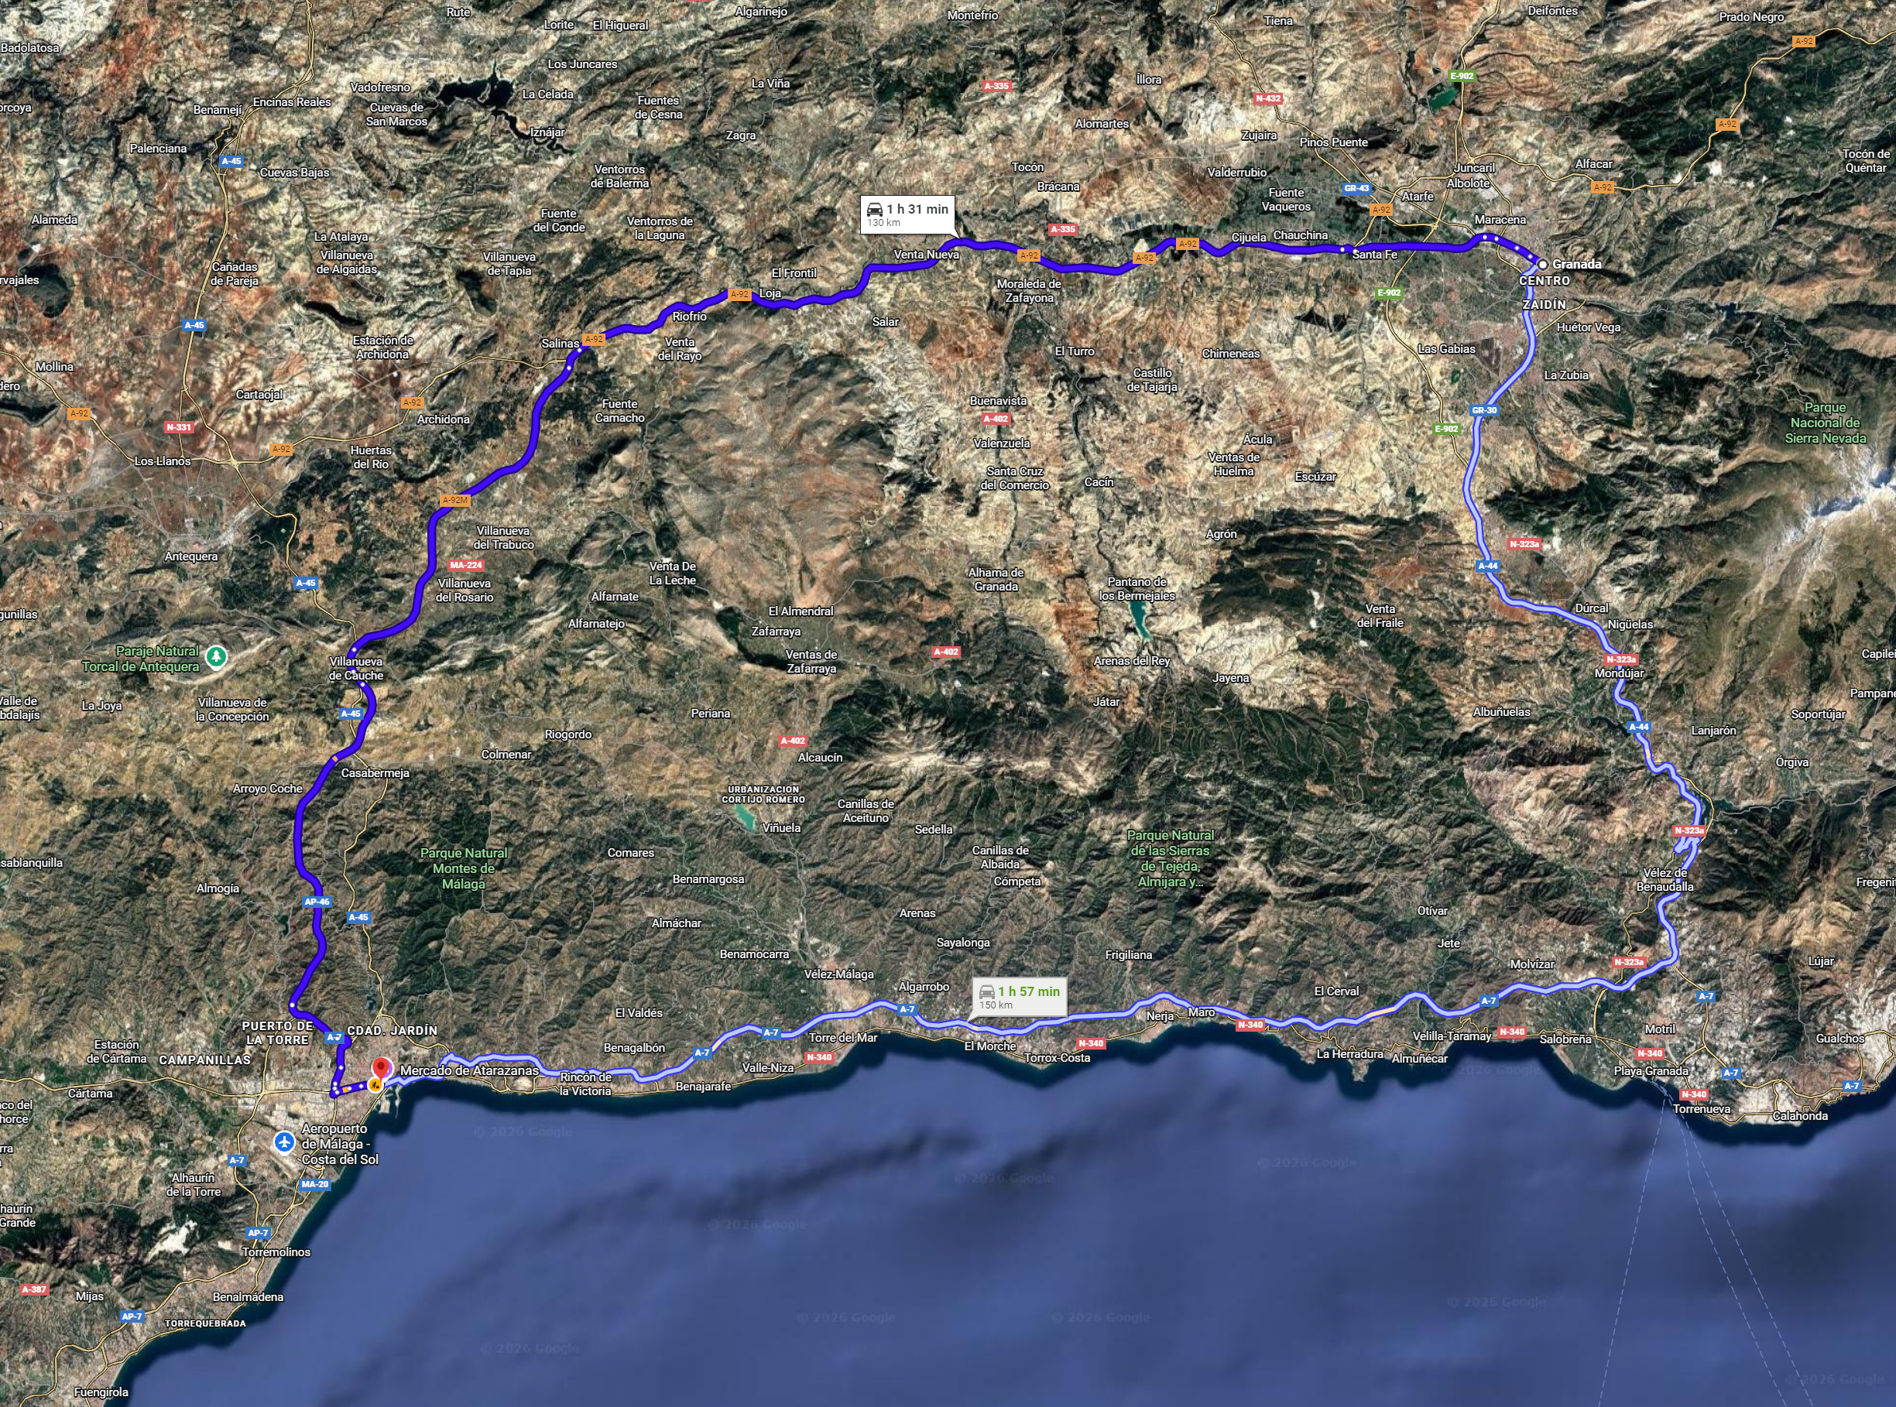

UNTERKUNFT MALAGA
DATUM 09/10/2026 bis 10/10/2026
MALAGA Hilton Garden Inn Malaga
Avenida de Velazquez, 126, Carretera de Cádiz, 29004 Málaga
+34 952 233 122
https://www.hilton.com/es/hotels/agpgigi-hilton-garden-inn-malaga

INFO MALAGA

- Malaga: città vivace sulla costa, patria di Pablo Picasso, con il suo museo, il castello di Gibralfaro e le spiagge cittadine.

Abgesehen von ihren 16 sonnigen Stränden hat diese Stadt in Andalusien am Mittelmeer ein äußerst interessantes Kulturleben zu bieten. Denn die Geburtsstadt Picassos hat sich in den letzten Jahren ein neues Gewand verliehen und Museen für jeden Geschmack eingeweiht.
Nehmen wir zu dieser Kombination aus Meer und Kultur noch das lebendige Ambiente, die reichlichen Tapas, Trendviertel wie El Soho, Gegenden wie das Hafenviertel, die sich heute von ihrer modernsten Seite zeigen, und jahrhundertealte Monumente, ist das Ergebnis eine für jeden Besucher aufregende Stadt. Wenn sich alle einig sind, dass Málaga schöner denn je ist, so muss dies wohl einen Grund haben.
Eine Zeitreise
Málaga ist eine Stadt voller historischer Winkel wie der Alcazaba, einer der größten arabischen Festungen Andalusiens, oder der Gibralfaro-Burg, von der aus man einen der schönsten Ausblicke über die Stadt genießen kann. Zu Füßen der Burg liegen das römische Theater und die Altstadt, die zu einem gemütlichen Spaziergang einlädt. In ihr verbergen sich Winkel wie der Atarazanas-Markt, auf dem man einen Wermut trinken kann, und Monumente wie die Kathedrale, die wegen ihres unvollendeten rechten Turms „Die Einarmige“ genannt wird. Ihre Dachterrasse zu erklimmen ist eine einmalige Erfahrung. Im Zentrum der Heimatstadt Picassos gibt es ein äußerst empfehlenswertes Museum über den Maler. Auch sein Geburtshaus kann man besichtigen.Aber Málaga ist nicht in der Vergangenheit stehen geblieben. So wurde unlängst das Carmen Thyssen-Museum, das einzige Centre Pompidou außerhalb Frankreichs, dessen bunter Würfel mittlerweile ein echtes Wahrzeichen geworden ist, oder die Sammlung des Russischen Museums Sankt Petersburg eröffnet.Wer eher Underground-Kultur sucht, sollte sich das Zentrum für Zeitgenössische Kunst, die urbane Kunst an den Häuserfassaden und die Lokale der alternativen Szene in Soho nicht entgehen lassen.
Das Wesen Málagas
Málaga zeichnet sich durch mehrere Besonderheiten aus. Als Erstes wäre jenseits der Monumente der ebenso sonnenverwöhnte wie bekannte Stadtstrand La Malagueta zu erwähnen. Wer voll in die traditionelle Küche eintauchen möchte, sollte im Fischerviertel Pedregalejo die typischen gegrillten Sardinenspieße Espetos probieren.Auf dem Rückweg von La Malagueta lädt direkt daneben der Kai 1 zu einem Spaziergang am Hafen ein, vorbei an den Läden und Restaurants, bis hin zur Farola, dem Leuchtturm, der das eigentliche Wahrzeichen der Stadt ist.Ein weiteres Aushängeschild Málagas? Ohne Zweifel die Fußgängerzone Calle Marqués de Larios, eine blumengeschmückte, belebte Allee, über die man mindestens einmal schlendern sollte. Abends verwandelt sich diese Gegend zum perfekten Tapas-Viertel. Besuchen Sie hier Lokale mit Rang und Namen wie die Bodega El Pimpi und stellen Sie selbst fest, wonach „Ajoblanco“ schmeckt.Aber Málaga ist auch für das Filmfestival, die Karwoche, die innovativen Restaurants und vieles mehr berühmt. Doch vor allem steht Málaga für Lebensfreude. Und die ist ansteckend.

Lista e mappa Malaga

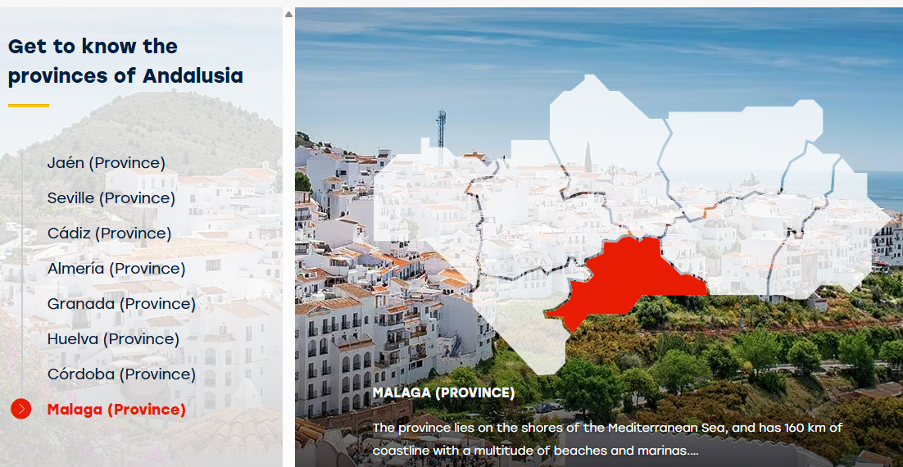

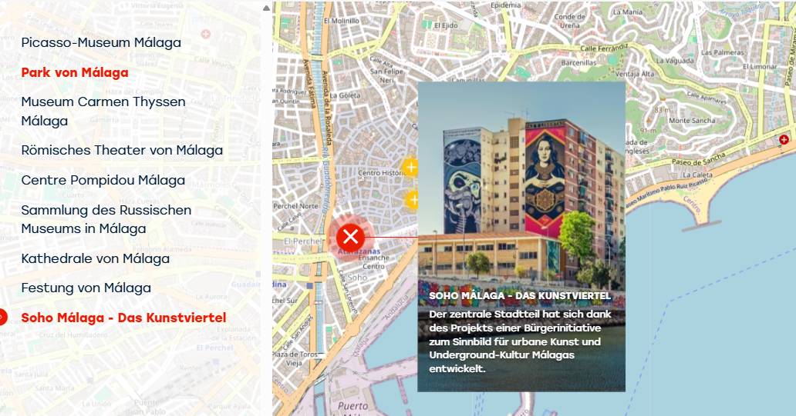

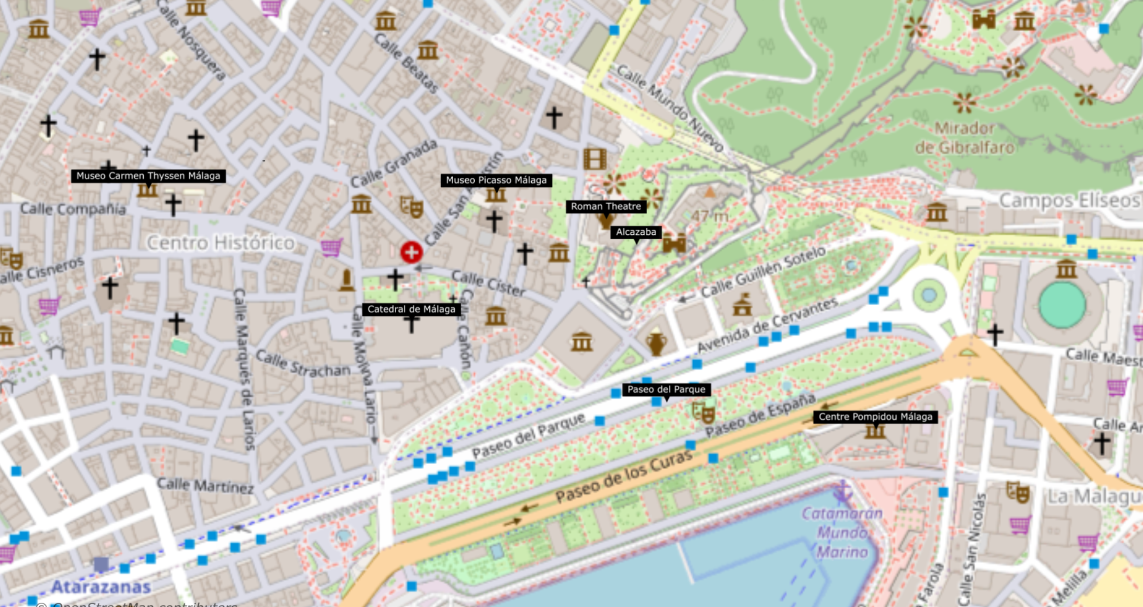

To visit in Malaga

Picasso-Museum Málaga
Das Museum war ein ausdrücklicher Wunsch von Pablo Picasso: Sein Werk sollte auch in seiner Heimatstadt zu sehen sein.
Das Picasso-Museum Málaga befindet sich im Buenavista-Palast, einem typischen Zivilgebäude der Renaissance in Andalusien. Die ständige Ausstellung umfasst eine Auswahl an Werken aus der Privatsammlung zweier Familienangehöriger, Christine Ruiz-Picasso und Bernard Ruiz-Picasso. Die über 200 Werke der Sammlung zeigen die unterschiedlichen Stile, Materialien und Techniken, derer sich der geniale Künstler bediente. Darüber hinaus werden mit Picasso in Zusammenhang stehende Sonderausstellungen, didaktische und kulturelle Aktivitäten veranstaltet.
Picasso-Museum Málaga
Palacio de Buenavista. Calle San Agustín 8
29015 Málaga (Andalusien)
info@mpicassom.org
Tel.:+34 952127600
https://www.museopicassomalaga.org/en

Park von Málaga
Die Gestaltung dieses Parks hat einen ausgeprägten landschaftlichen Charakter mit überwiegend geschwungenen Wegen, die Inseln unterschiedlicher Größe einrahmen und abgrenzen, so dass das Gefühl, sich in einem streng rechteckigen Raum zu befinden, verloren geht. Innerhalb der Struktur gibt es verschiedene Punkte, die hervorstechen, beispielsweise die verschiedenen Pavillons, darunter der Musikpavillon, die verschiedenen Brunnen und die zahlreichen Statuen, die im ganzen Garten verteilt sind. Viele von ihnen sind berühmten Persönlichkeiten aus Málaga oder Personen, die mit Málaga verbunden sind, gewidmet, darunter dem Maler Bernardo Ferrándiz oder den Schriftstellern Salvador Rueda, Narciso Díaz de Escovar, Rubén Darío und Arturo Reyes. Die vorhandene Vegetation ergänzt diese freie und natürliche Gestaltung perfekt.
Park von Málaga
Paseo del Parque, 1
29016 Málaga (Andalusien)
E-Mail:info@malagaturismo.comTel.:+34 952 262 461
https://visita.malaga.eu/es/que-ver-y-hacer/visitas/monumentos-historicos/parques-y-jardines-historicos/parque-de-malaga-p103346

Museum Carmen Thyssen Málaga
Die Sammlung des Museums umfasst Werke unterschiedlicher Genres, die die spanische Malerei des 19. Jahrhunderts prägten. Im Mittelpunkt stehen dabei die Künstler aus Andalusien.
Insgesamt werden im Villalón-Palast in Málaga, einem Mitte des 16. Jahrhunderts errichteten Bau, mehr als 200 Kunstwerke gezeigt. Den Anfang der Ausstellung bildet eine Reihe von Gemälden alter Meister, von denen insbesondere die „Santa Marina“ von Zurbarán zu erwähnen ist. Im Anschluss daran befindet sich ein der romantischen Landschaftsmalerei und dem Kostumbrismus gewidmeter Bereich, in dem Werke von Genaro Pérez Villaamil, Manuel Barrón oder der Familie Domínguez Bécquer zu sehen sind. Mit Marià Fortuny schließlich taucht der Besucher ein in die preziöse Malerei und die naturalistischen Landschaften, um danach Meisterwerke der spanischen Kunst vom Ende des letzten Jahrhunderts zu betrachten, darunter Arbeiten von Joaquín Sorolla, Anglada i Camarasa, Ignacio Zuloaga und Julio Romero de Torres. Darüber hinaus veranstaltet das Museum regelmäßig temporäre Ausstellungen.
Museum Carmen Thyssen Málaga
Plaza Carmen Thyssen - Calle Compañía 10
29008 Málaga (Andalusien)
E-Mail:info@carmenthyssenmalaga.org
Tel.:+34 952 217 511
Tel.:+34 902 303 131
https://www.carmenthyssenmalaga.org/en/

Römisches Theater von Málaga
ach langem Begräbnis kam es wieder zum Vorschein.
Jahrhundertelang lag das Theater von Málaga unter Erdmassen begraben.
Das römische Theater von Málaga liegt am Fuß des Cerro de la Alcazaba, im westlichen Bereich. Nachdem es jahrhundertelang versunken gewesen war, wurde es 1951 wiederentdeckt. Errichtet wurde es im 1. Jahrhundert, zur Regierungszeit von Kaiser Augustus. In Gebrauch blieb es bis ins 3. Jahrhundert. Die Araber verwendeten Bauteile davon, wie Säulenschäfte und -kapitelle, zum Bau ihrer Alcazaba, also der Festung, wo sie als Stütze für die Hufeisenbögen der Portale dienten. Seine Dimensionen bemessen sich in 31 Meter im Radius, 16 Meter Höhe und 15 Meter im Orchesterraum. Unterscheidbar ist eine Zone von drei Rangreihen und Eingangstüren zum Publikumsraum (Vomitorium).
Römisches Theater von Málaga
Calle Alcazabilla, s/n
29015 Málaga (Andalusien)
teatroromanomalaga.ccul@juntadeandalucia.es
Tel.:+34 671 539 212
Tel.:+34 951 501 115
//visita.malaga.eu/de/was-zu-sehen-und-zu-tun/kultur/historische-monumente/monumente/romisches-theater-p103562
Mail-Adresse für Reservierungen:TRomanoMalaga.aaiicc@juntadeandalucia.es

Centre Pompidou Málaga
Centre Pompidou Málaga
Die Heimatstadt Picassos beherbergt den ersten Sitz dieser Pariser Institution außerhalb Frankreichs. Die ständige Sammlung zeigt mehr als 80 Werke großer Künstler wie Picasso, Miró, Speck, Magritte, Frida Khalo und Giacometti. Ein privilegierter Zugang zur Kunst des 20. und 21. Jahrhunderts.
Das neue Centre Pompidou ist mehrere Jahre lang in Málaga in dem originellen Gebäude El Cubo mitten im Hafen der Stadt mit Blick auf die Bucht untergebracht.Der Besucher findet dort eine Werkauswahl aus der Sammlung des Centre Pompidou auf einer Fläche von 2.000 Quadratmetern. Neben der ständigen Ausstellung bietet dieses Zentrum auch Wechselausstellungen und ein volles Kulturprogramm mit Aktivitäten im Zusammenhang mit Tanz, Aufführung, Film u.v.m.
Centre Pompidou Málaga
Pasaje Doctor Carrillo Casaux, s/n. Muelle Uno, Puerto de Málaga
29016 Málaga (Andalusien)
info.centrepompidou@malaga.eu
Tel.:+34 951926200
https://centrepompidou-malaga.eu/plan-your-visit/
Tel. für Reservierungen:+34 902998631

Kathedrale von Málaga
Einer der schönsten Sakralbauten der andalusischen Renaissance.
Die Errichtung des Bauwerks wurde vom katholischen Königspaar angeordnet. Das Gotteshaus ist im Volksmund auch als 'La Manquita' ('Die Einarmige') bekannt.
Die Catedral de la Encarnación gehört zu den wichtigsten Bauwerken der Stadt. Der Südturm und die Hauptfassade sind unvollendet geblieben. Die Kathedrale, welche am ehemaligen Standort einer Moschee-Mauernviertel errichtet wurde, befindet sich im historischen Zentrum der Stadt. Die Bauarbeiten begannen in der ersten Hälfte des 16. Jh. im gotischen Stil auf Auftrag des katholischen Königspaars und gingen im 17. und 18. Jh. weiter. Es gibt eigene Gärten und einen wunderbaren Innenhof. Innen ist die Kathedrale durch Renaissance und Barock beeinflusst. Im Wesentlichen stechen ihr Chorgestühl (17. Jhdt.) im Mittelschiff und vor allem die Bildhauereien von Pedro de Mena hervor. Auch die Kapellen sind äußerst sehenswert, so die Capilla de la Encarnación, welche der Kathedrale auch ihren Namen gibt.
Kathedrale von Málaga
Calle Molina Lario, 9
29015 Málaga (Andalusien)
catedral@diocesismalaga.es
jesus@artisplendore.com
Tel.:+34 617 500 582
https://malagacatedral.com/la-catedral/
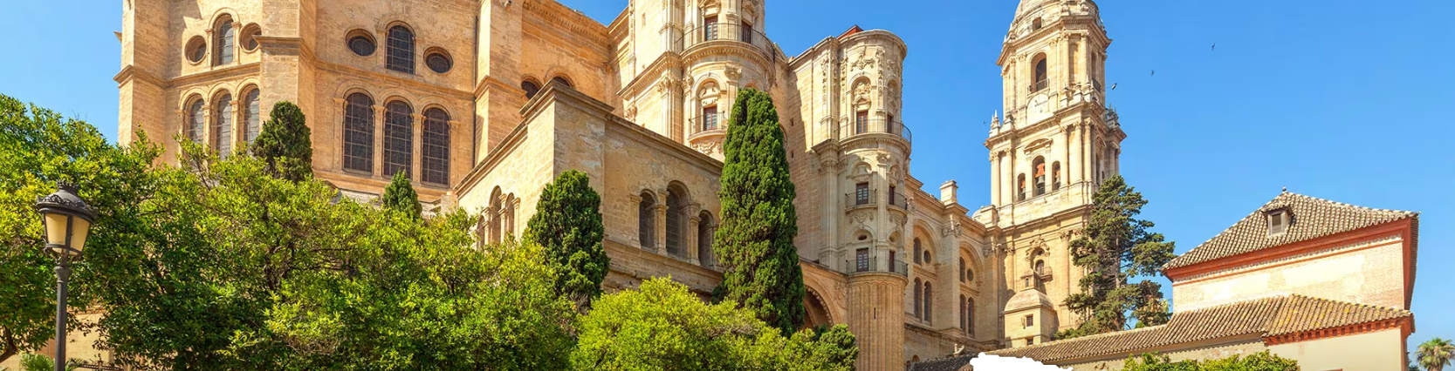

Festung von Málaga
Diese arabische Palastfestung wurde im 11. Jahrhundert auf Befehl des Herrschers Badis von Granada errichtet. Sie ist der Topografie perfekt angepasst und nutzt einen vorhandenen Hügel. Es sind zwei konzentrische Bereiche zu unterscheiden. Der äußere Ring ist weniger hoch. Im inneren Bereich befindet sich der Palast.
Festung von Málaga
Calle Alcazabilla, 2
29012 Málaga (Andalusien)
gmpalcazaba@malaga.eu
Tel.:+34 630 932 987
Tel.:+34 952 227 230
https://alcazabaygibralfaro.malaga.eu/es/alcazaba/historia/

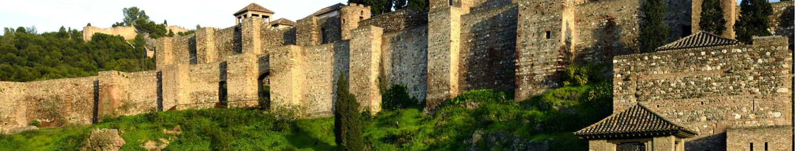

Soho Málaga - Das Kunstviertel
Der zentrale Stadtteil hat sich dank des Projekts einer Bürgerinitiative zum Sinnbild für urbane Kunst und Underground-Kultur Málagas entwickelt.
Am auffälligsten sind wohl die großflächigen Graffitis, die einige seiner Gebäude zieren. An diesen Mauern sind Arbeiten international bekannter Graffiti-Künstler wie Obey oder D*face zu bewundern. Das Viertel lässt sich gut zu Fuß erkunden und befindet sich ganz in der Nähe des Haupttouristengebietes Málagas. In seinen Straßen kann man unabhängige Läden mit viel Charakter, mehrere Kunst- und Kulturstätten wie Privatgalerien, Ateliers, das Theater La Alameda oder das Zentrum für Zeitgenössische Kunst neben unzähligen Bio-, Gourmet- und traditionellen Restaurants oder Plätze mit ebenso modernem wie funktionalem Stadtmobiliar entdecken. Außerdem findet jeden ersten Samstag im Monat der Markt „Made in Soho“ statt, auf dem Designerstücke, Kunsthandwerk, plastische und audiovisuelle Kunst, Antiquitäten und Vintage-Produkte dargeboten werden.El Soho oder das Kunstviertel „Barrio de las Artes“ ist das Ergebnis eines Projektes, das auf eine Bürgerinitiative zur Belebung der Gegend zurückgeht und mittlerweile mit der Unterstützung der Institutionen rechnen kann.Lage: Neben dem Hafen von Málaga. Im Süden grenzt es an La Alameda, den Kai Heredia, den Plaza de La Marina und den Fluss Guadalmedina.
Soho Málaga - Das Kunstviertel
Ensanche Heredia. Distrito Centro
29001 Málaga (Andalusien)
info@sohomlg.com

- Ronda: famosa per il suo ponte spettacolare che collega le due parti della città, costruita su una profonda gola.
- Villaggi bianchi (Pueblos Blancos): come Mijas, Arcos de la Frontera e Frigiliana, caratteristici per le case imbiancate a calce e le viuzze tortuose.
- Parco Nazionale di Doñana: una delle aree naturali più importanti d’Europa, ideale per il birdwatching e le escursioni.
- 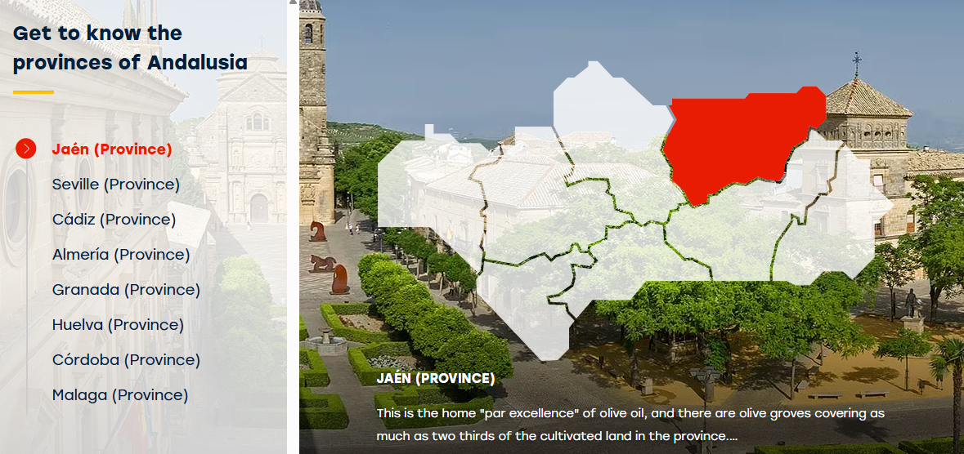
- 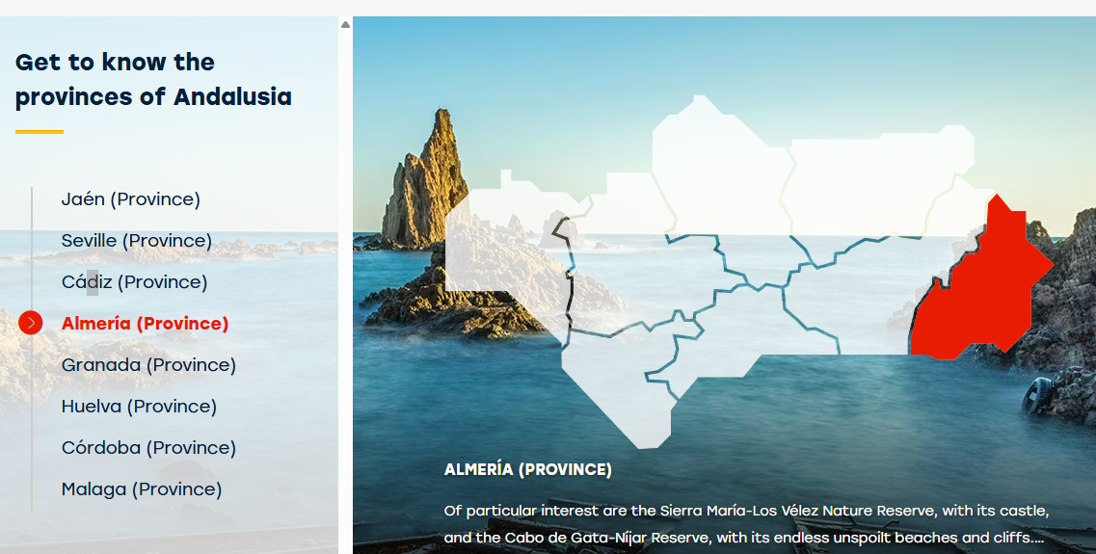
- 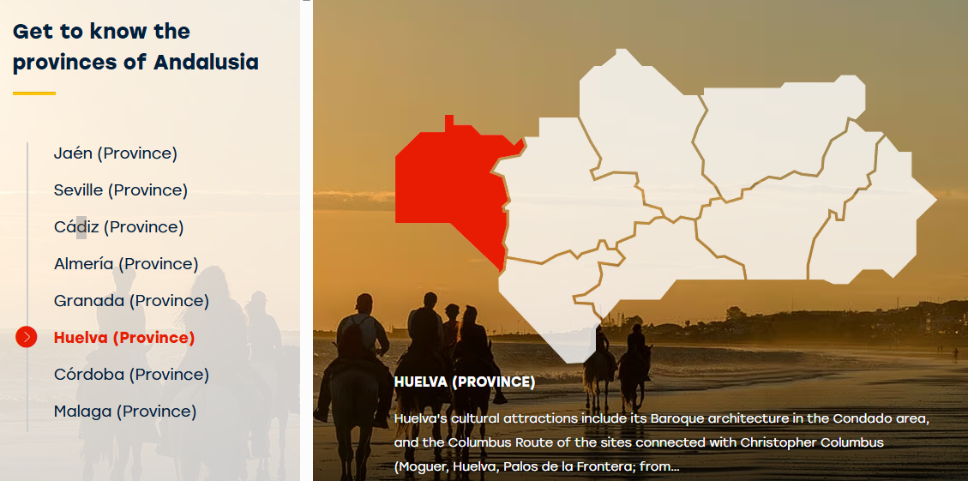

Mappa dell’Andalusia
La mappa qui sotto evidenzia le principali città e attrazioni della regione:
Visualizza la mappa interattiva dell'Andalusia su Google Maps
In sintesi, un viaggio in Andalusia offre un mix unico di arte, natura, gastronomia e tradizioni, il tutto immerso in un’atmosfera calorosa e accogliente tipica del sud della Spagna. Come si dice da queste parti, "Andalusia è un sentimento che si vive con il cuore".

Spain.info.de

